**Assignment L05 - Image Classification with SVM**

**Team EyeConic**

**Brooke Broderick - W217065417**

**Matthew Choo - W206744145**

**Cameroun White-W216530571**

**Melvis Maduagwu-W216890463**

**Erick Banegas - W216200956**

**NancyChieu-W000098778**

**Yoana Cook - W215913890**

**6252-ITAI-1378-Comp Vision-Artificial Intel-RT-15698 - Spring 2025**

**Professor Anna Devarakonda**

**February 22, 2025**

**Intro:**

* **In L05, Team Eye Conic will be looking at two ipynb. They are 0924Subset_Classical_ML_Image_Classification_with_CIFAR_10_Subset_of_Dataset_.ipynb and 2024 Image Processing and ML for CV with creating dataset.ipynb. These files both talk about dataset and produce different types of images.**

**0924Subset_Classical_ML_Image_Classification_with_CIFAR_10_Subset_of_Dataset -**

**Goal: In this notebook, we are to explore the basics of image classification by using CFIR-10 dataset and building a simple image classifier using Scikit-Learn. In figure 1, it shows installing and importing libraries. Then in figures 2 and 3 shows the loading and preprocessing of the CIFAR-10 Dataset. Lastly, figures 4 and 5 shows the Training a Machine Learning Model using SVM (Support Vector Machine).**

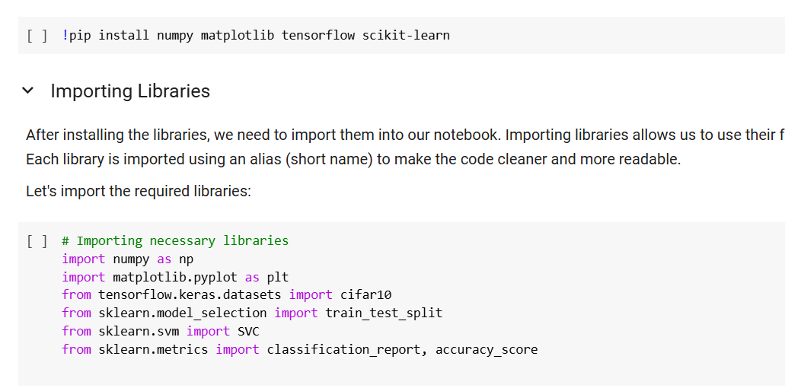

**Fig 1: Installing and Importing Libraries**

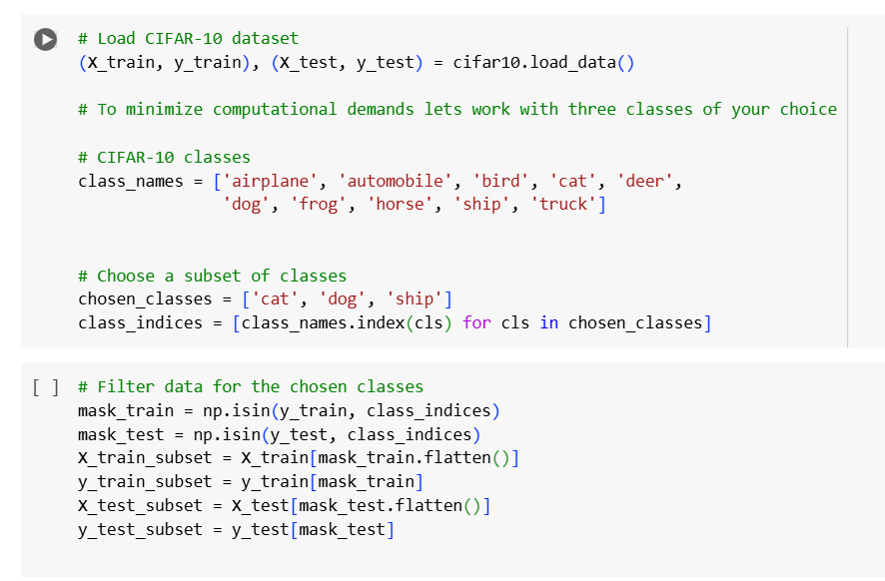

**Fig 2: Loading and Preprocessing the CIFAR-10 Dataset Part 1**

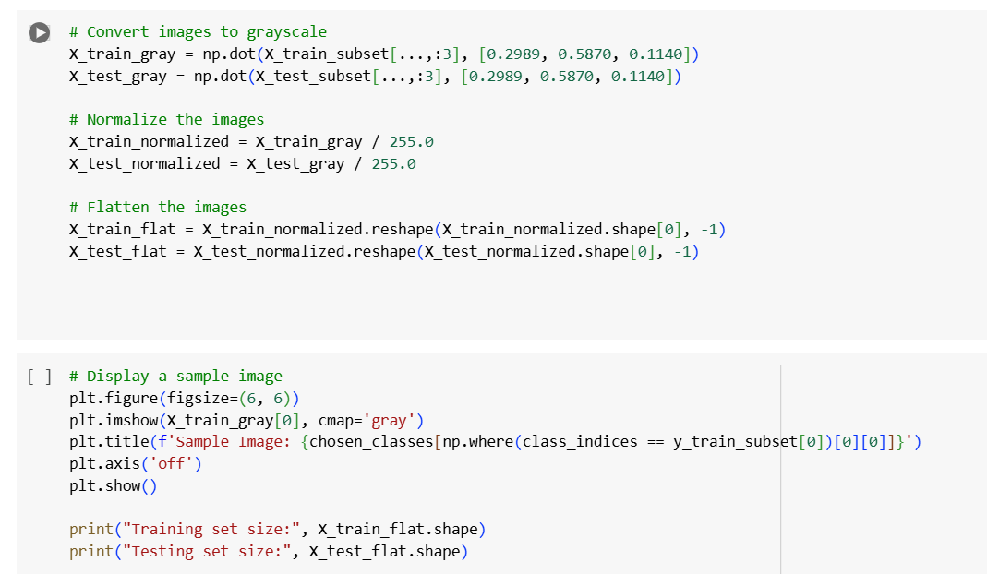

**Fig 3: Loading and Preprocessing the CIFAR-10 Dataset Part 2**

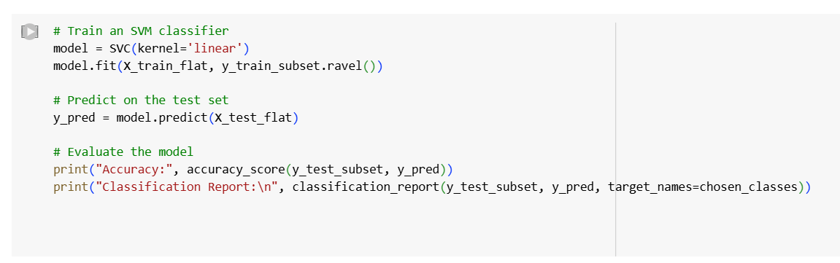

**Figure 4: Training a Machine Learning Model using SVM (Support Vector Machine) Part 1**

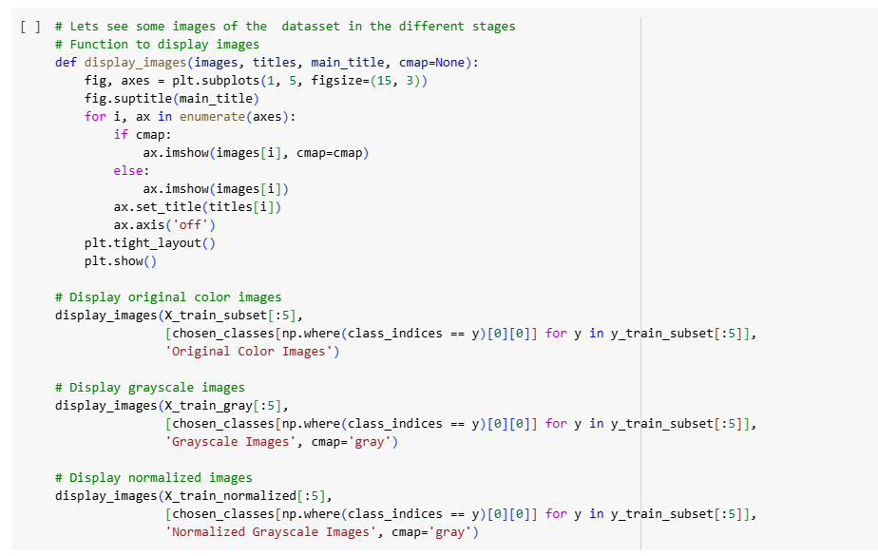

**Figure 5: Training a Machine Learning Model using SVM (Support Vector Machine) Part 2**

**2024 Image Processing and ML for CV with creating dataset**

**Goal: In this notebook, we will be exploring the basics of image processing by using OpenCv and building a simple image classifier using Scikit-Learn. In figures 6, we will be importing these libraries. Then in figure 7, we need to prepare a dataset where we have to get the “Dogs vs Cats” file in Kaggle.com. Next, In figure 8, is where we have to load and preprocess the images from the “Dogs vs Cats” file. After that in figure 9, we will have to split the data and do the SVM model shown in figure 10.**

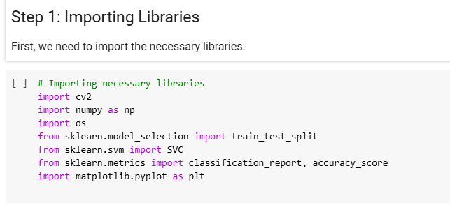

**Fig 6: Importing Libraries**

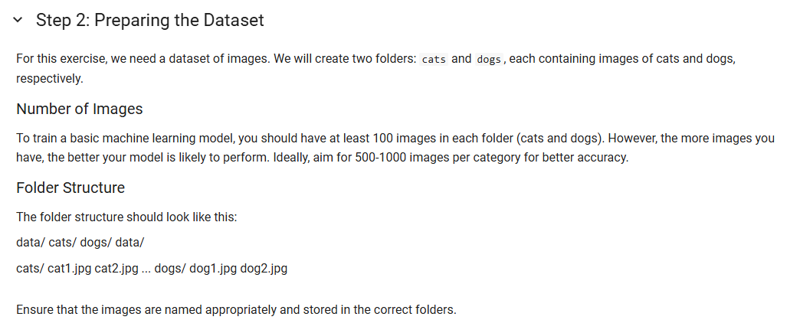

**Fig 7: Preparing the Dataset**

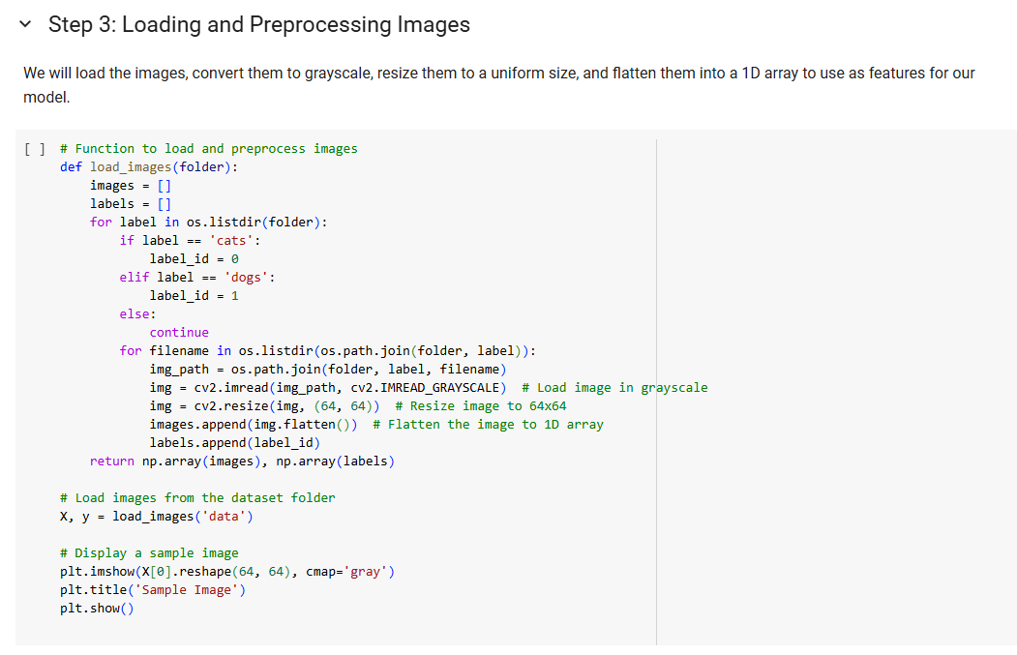

**Fig 8: Loading and Preprocessing Images**

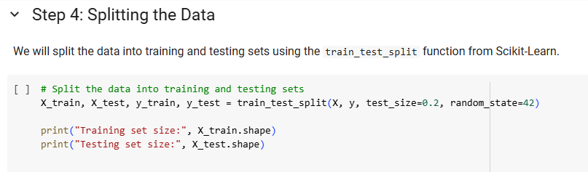

**Fig 9: Splitting Data**

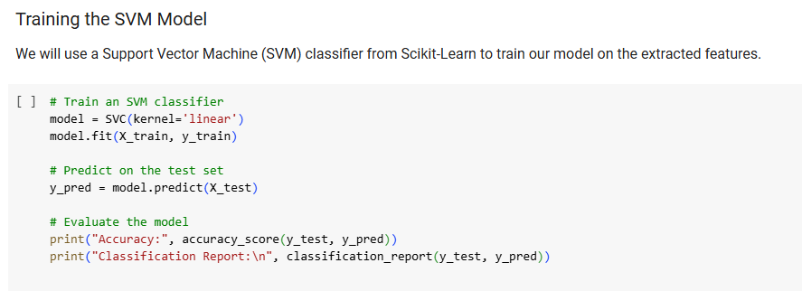

**Fig 10: SVM Model**

**0924Subset_Classical_ML_Image_Classification_with_CIFAR_10_Subset_of_Dataset - Results** 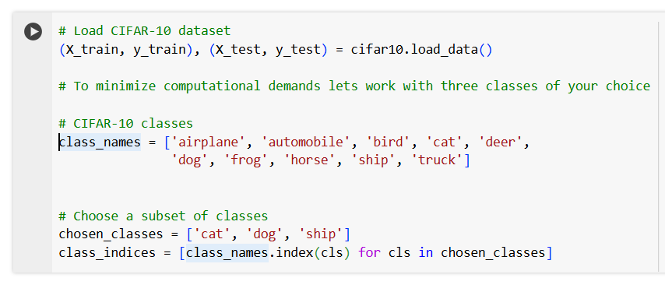

**Fig 11: Loading the CIFAR-10 Dataset (Matt)**

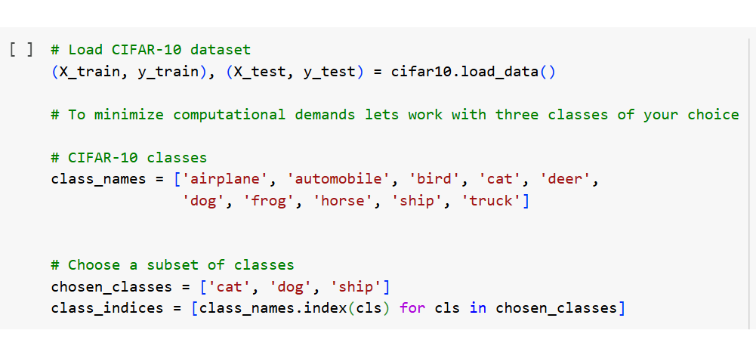

**Fig11-N: Load CIFAR-10 dataset, Nancy**

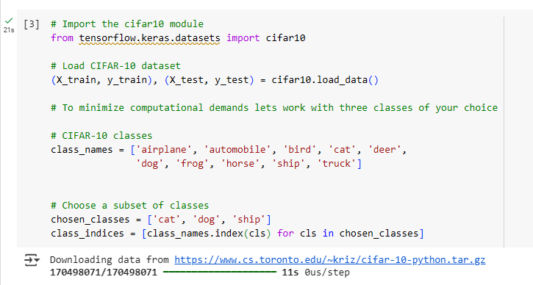

**Fig 11: Loading the CIFAR-10 Dataset (Brooke)**

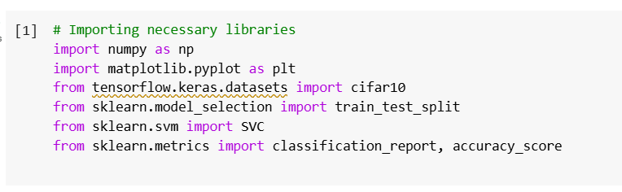

**Fig 12: Importing Libraries (Matt)**

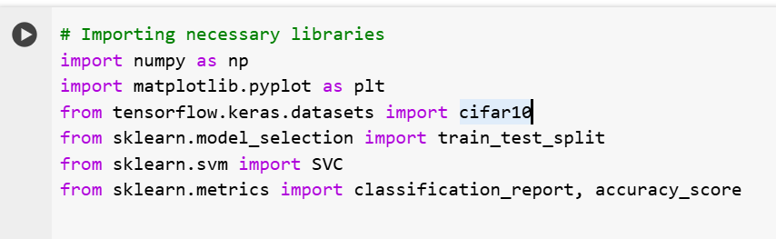

**Fig 12-N: Import Libraries, Nancy**

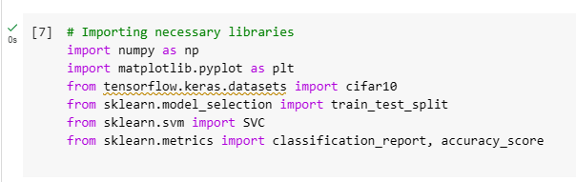

**Fig 12: Importing Libraries (Brooke)**

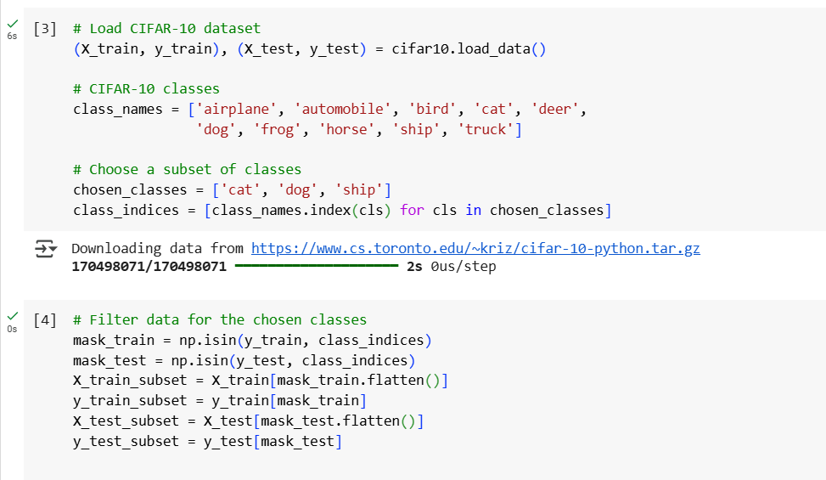

**Fig 13: Loading and Preprocessing the CIFAR-10 Dataset Part 1 (Matt)**

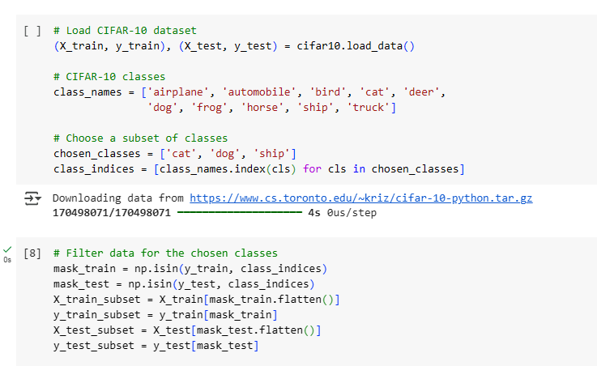

**Fig 13: Loading and Preprocessing the CIFAR-10 Dataset Part 1 (Brooke)**

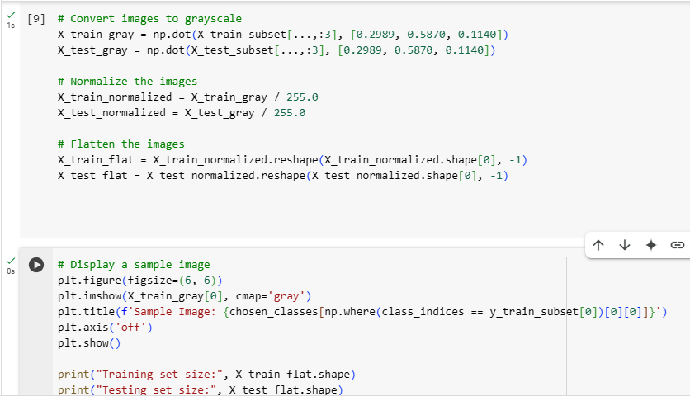

**Fig 14: Loading and Preprocessing the CIFAR-10 Dataset Part 2 (Brooke)**

**Fig 12-Y: Import Libraries, Yoana.**

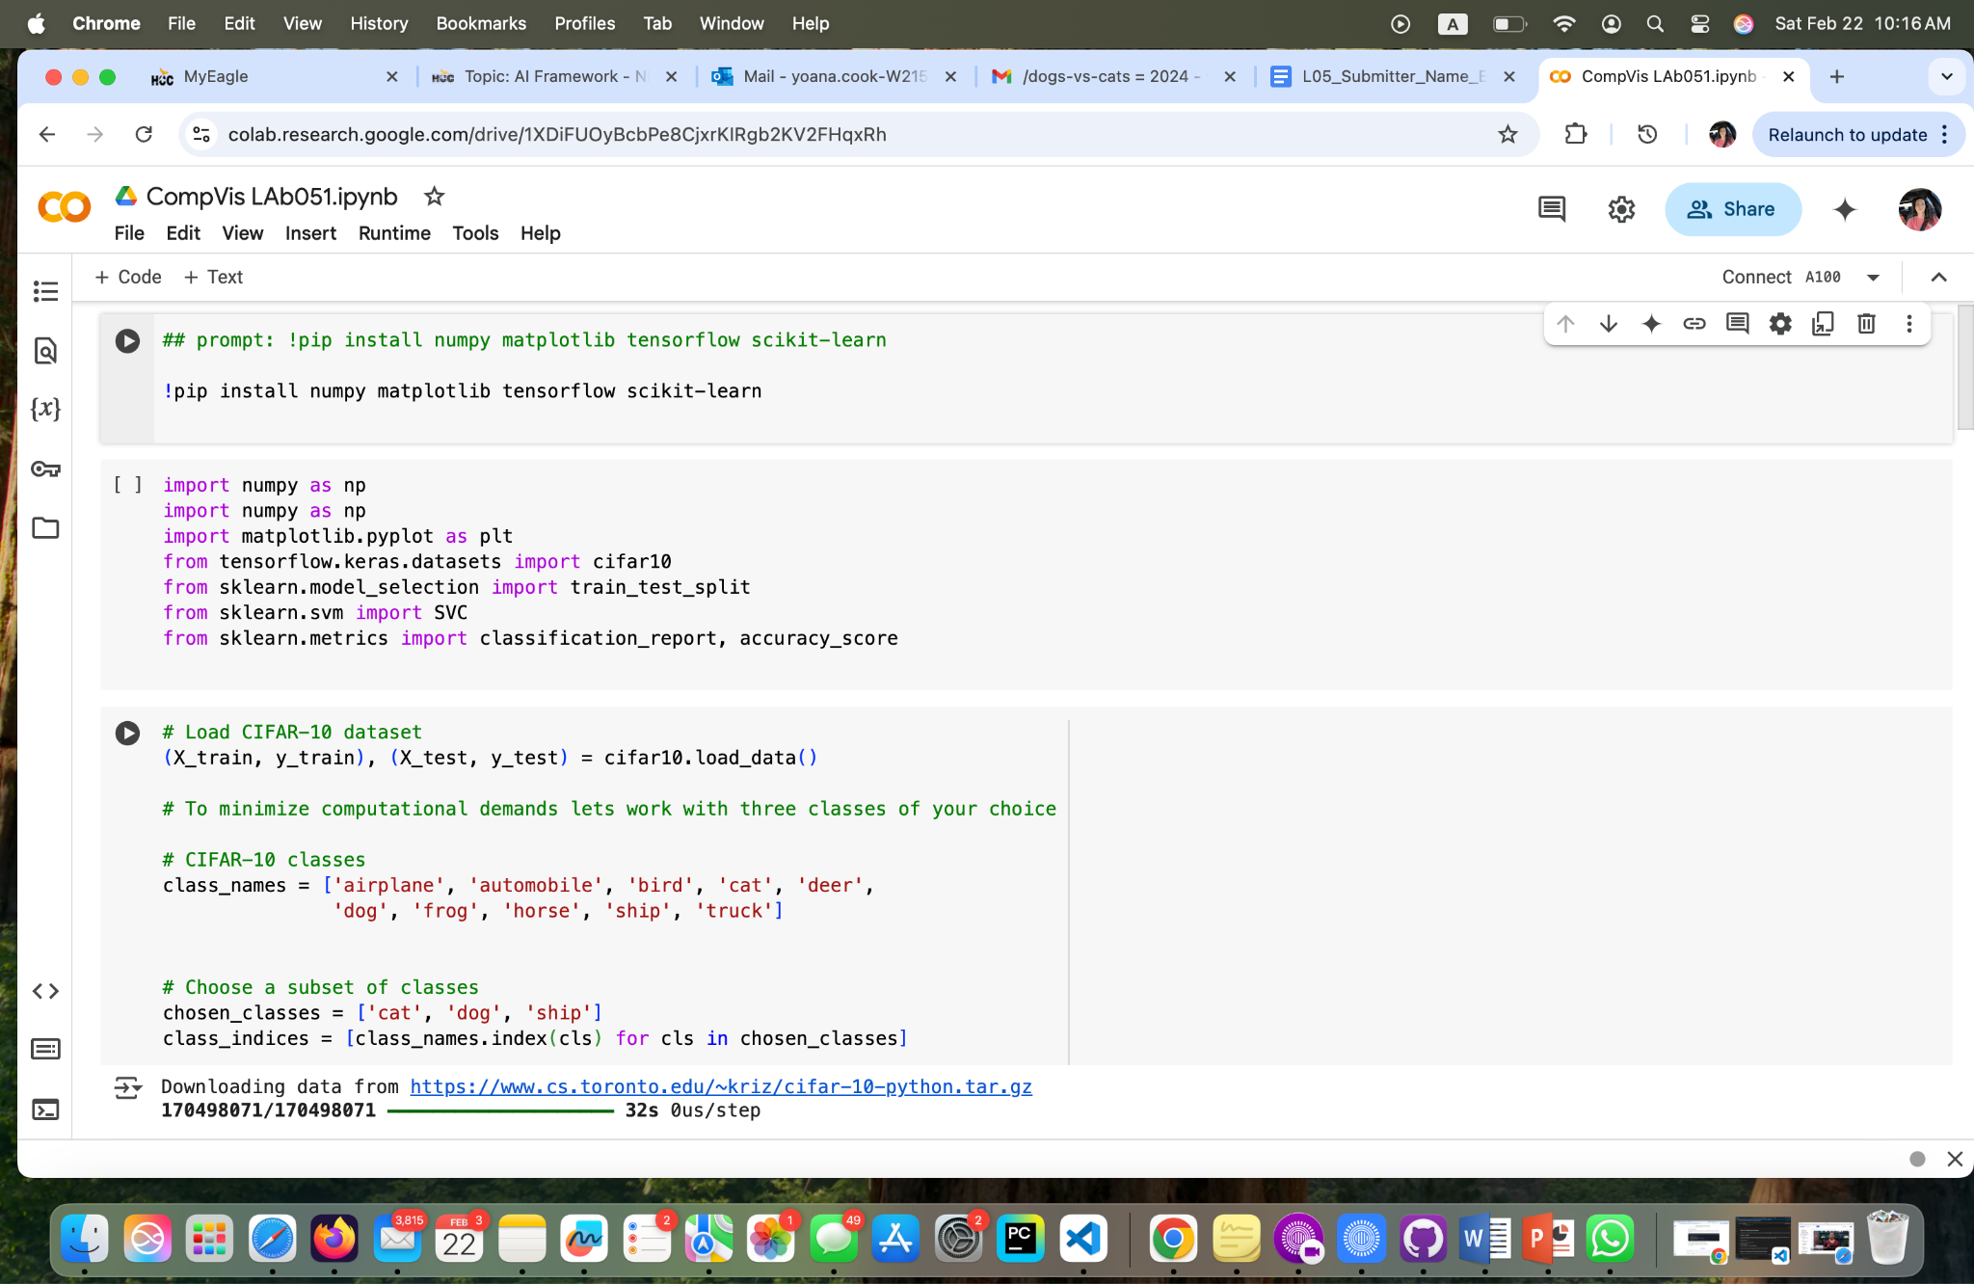

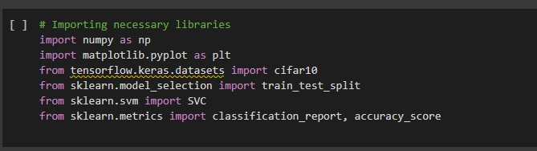**Fig 12-C: Importing Libraries, Cam**

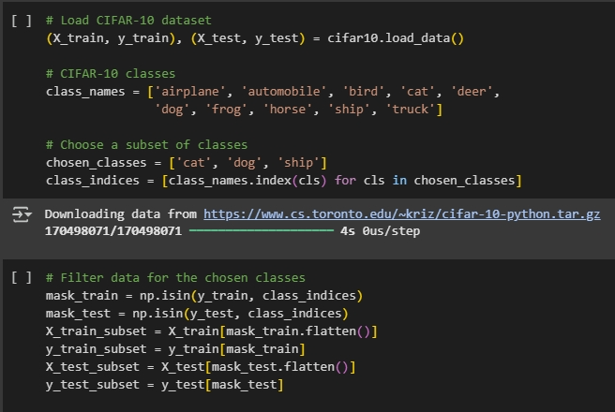**Fig 13: Loading and Preprocessing CIFAR-10 (Cam)**

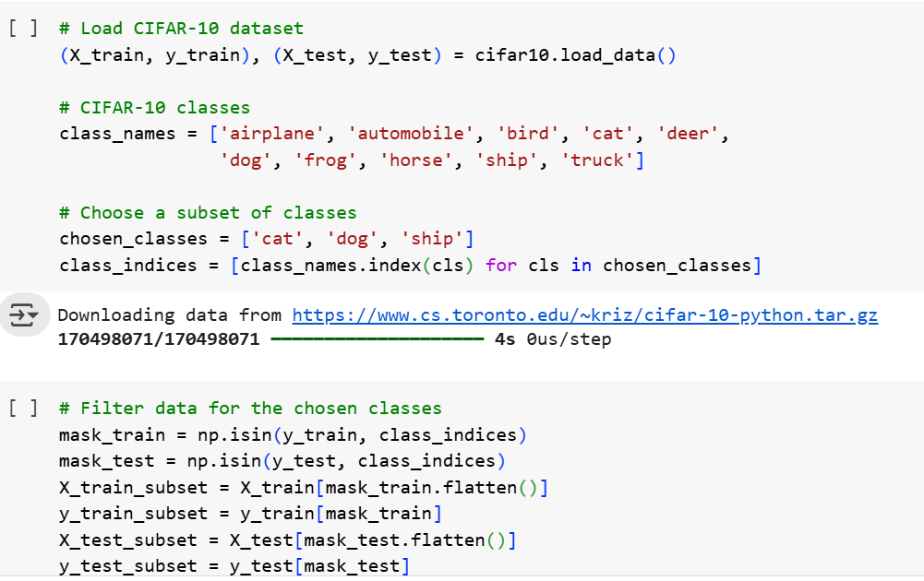

**Fig 13-N: Load and Preprocess the CIFAR-10 Dataset Part 2, Nancy**

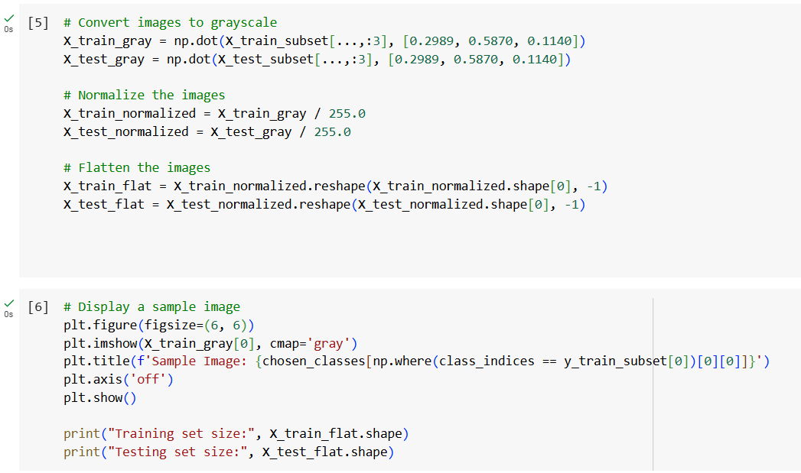

**Fig 14: Loading and Preprocessing the CIFAR-10 Dataset Part 2 (Matt)**

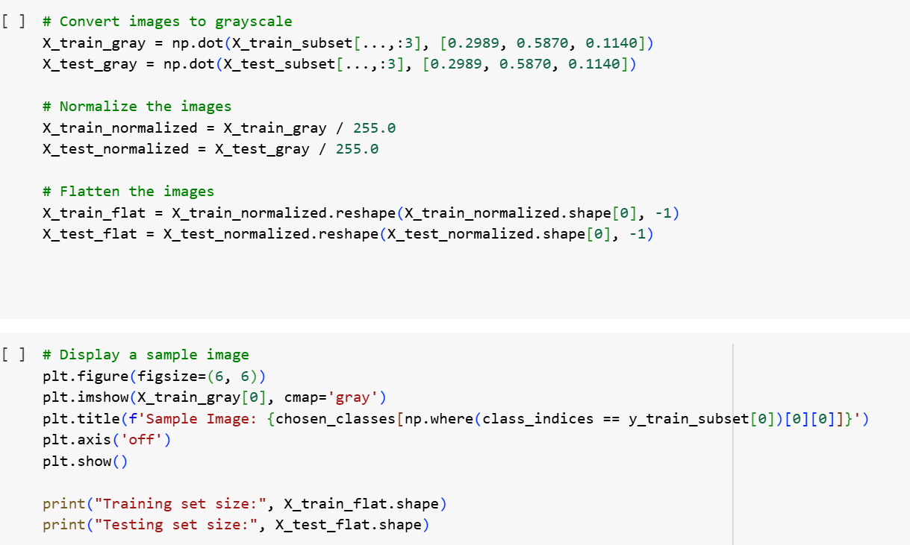

**Fig 14-N: Load and Preprocess the CIFAR-10 Dataset Part 2, Nancy**

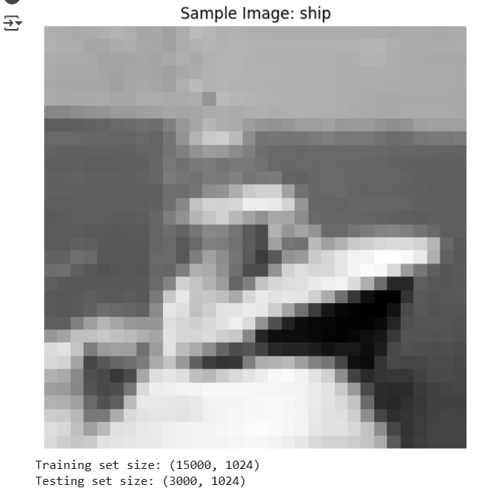

**Fig 15: Loading and Preprocessing the CIFAR-10 Dataset Part 3 (Matt)**

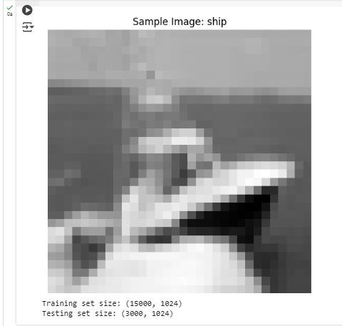

**Fig 15: Loading and Preprocessing the CIFAR-10 Dataset Part 3 (Brooke)**



**Fig 15-N: Load and Preprocess the CIFAR-10 Dataset Part 3, Nancy**

**Fig 14-Y: Load and Preprocess the CIFAR-10 Dataset Part 2, Yoana**

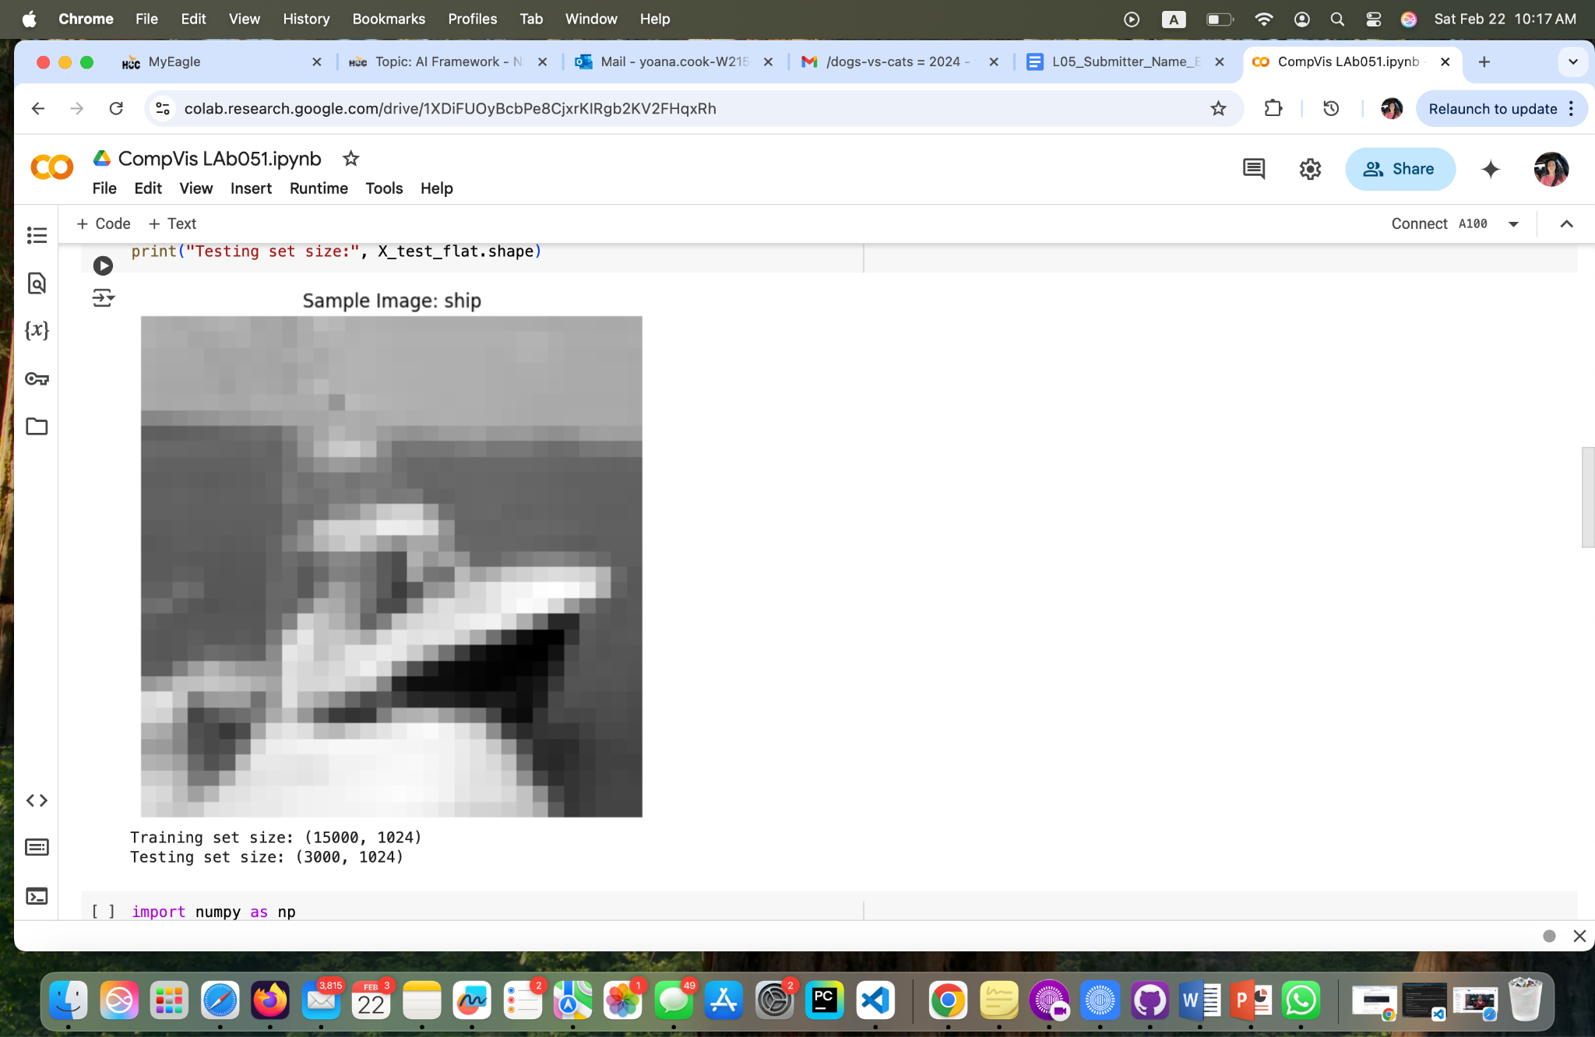

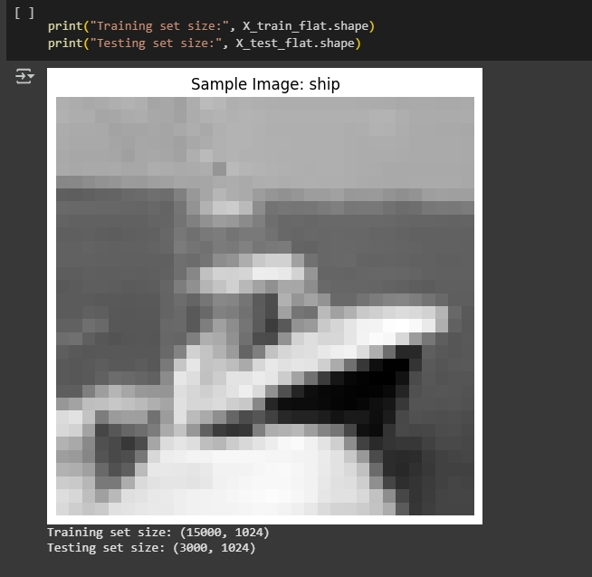

**Fig 14-C: Load and Preprocess the CIFAR-10 Dataset Part 2(Cam)**

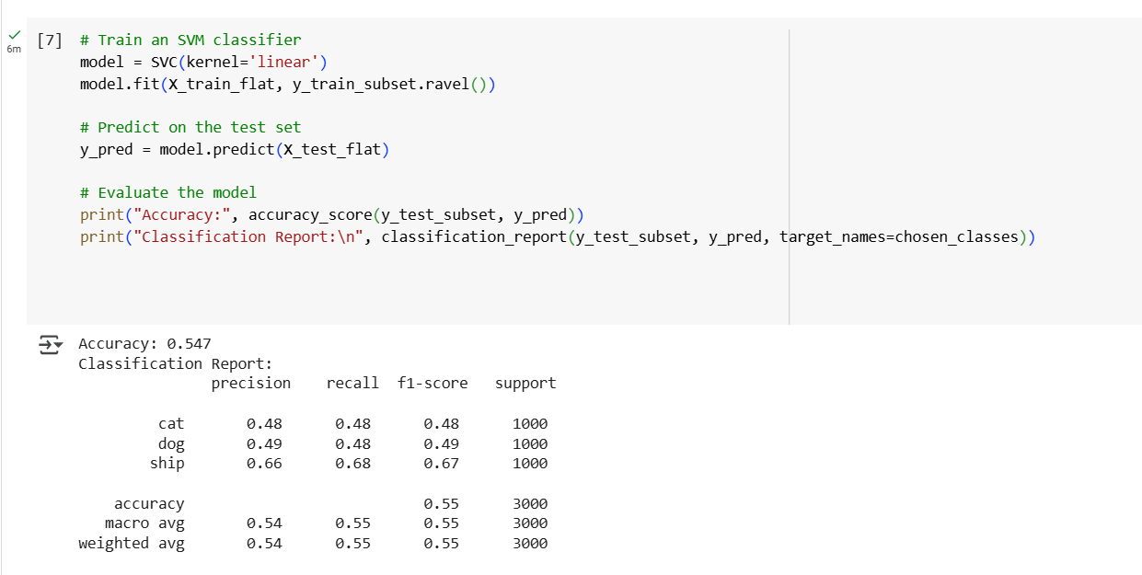

**Fig 16: Training a Machine Learning Model Part 1 (Matt)**

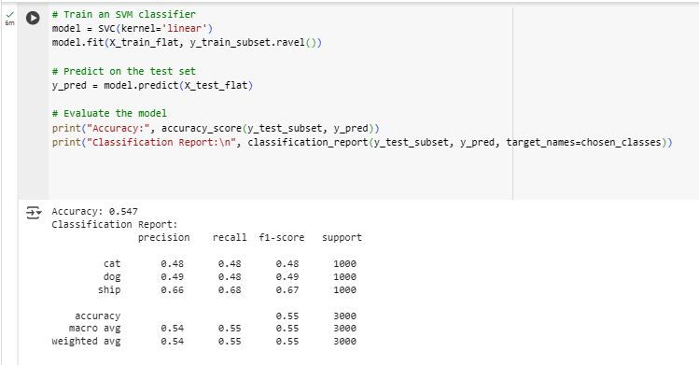

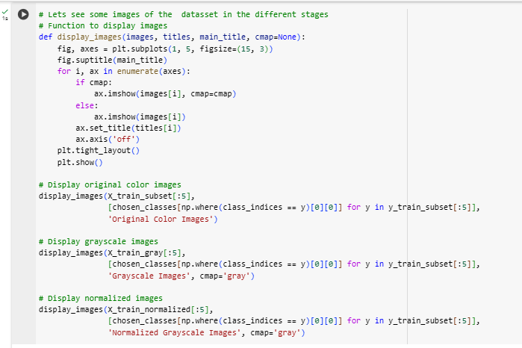

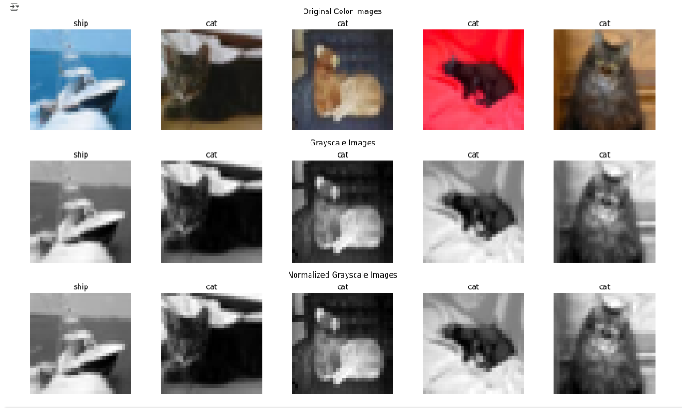

**Fig 16: Training a Machine Learning Model (Brooke)**

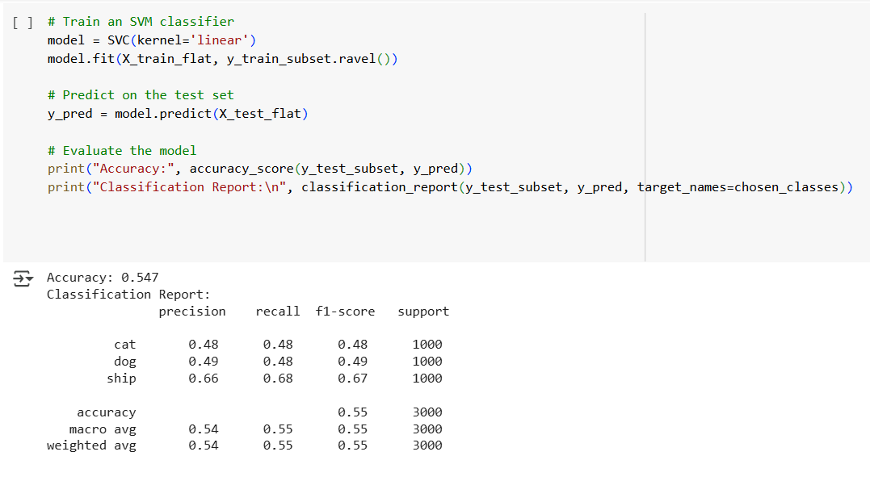

**Fig 16-N: Train a Machine Learning Model Part 1, Nancy**

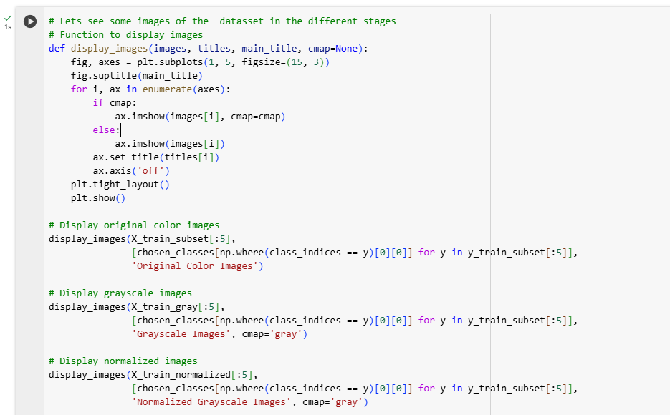

**Fig 17: Training a Machine Learning Model Part 2 (Matt)**

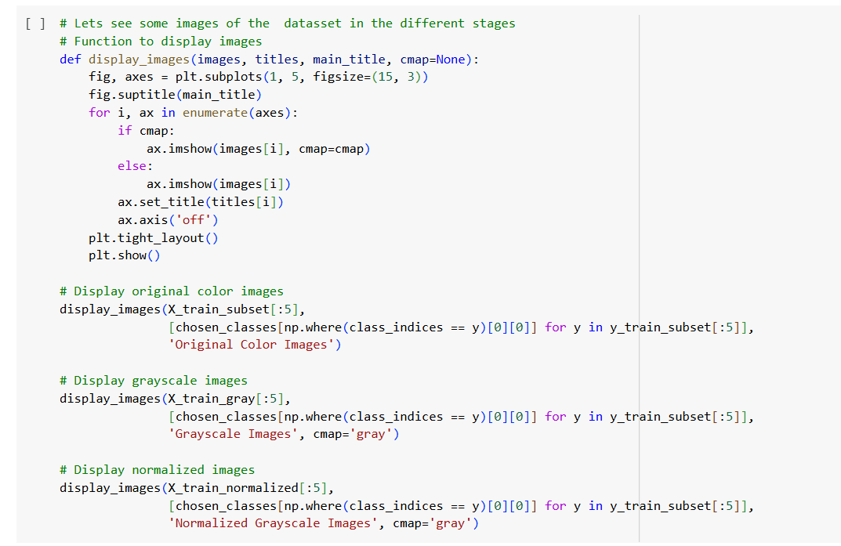

**Fig 17-N: Train a Machine Learning Model Part 2, Nancy**

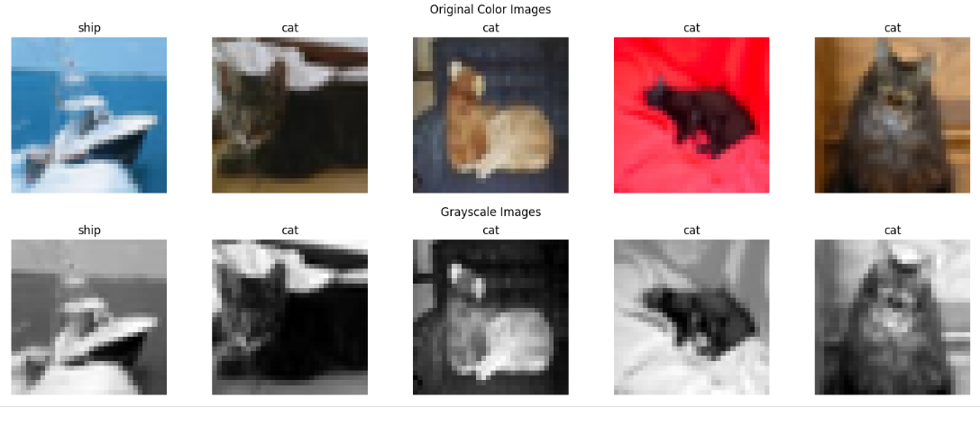

**Fig 18-N: Train a Machine Learning Model Part 3, Nancy**

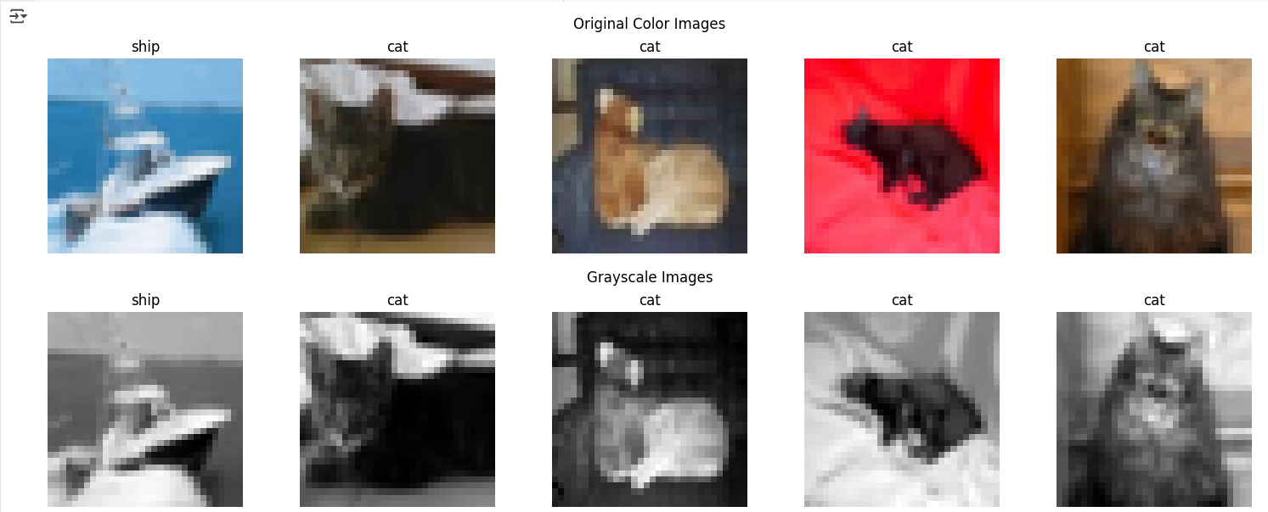

**Fig 18: Training a Machine Learning Model Part 3**

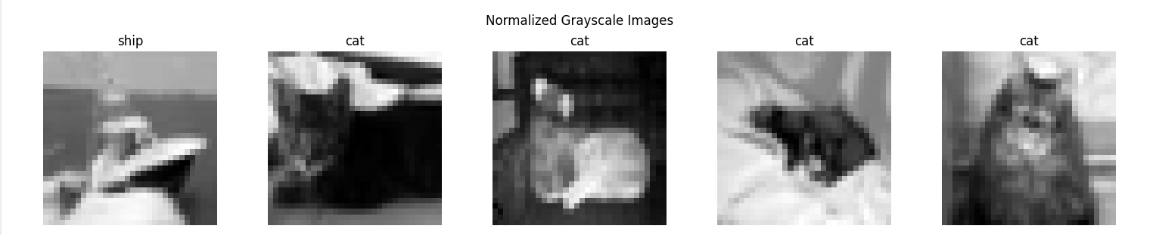

**Fig 19: Training a Machine Learning Model Part 4 (Matt)**

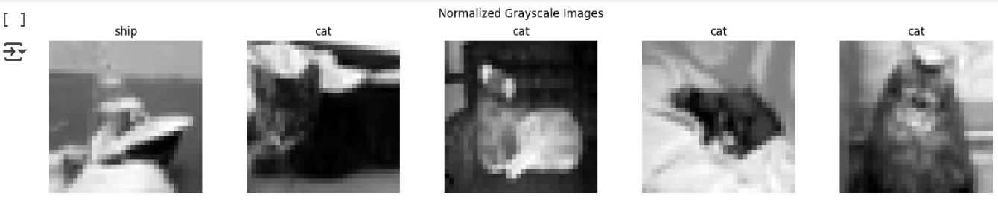

**Fig 19-N: Train a Machine Learning Model Part 4, Nancy**

**Installing numpy (Erick)**

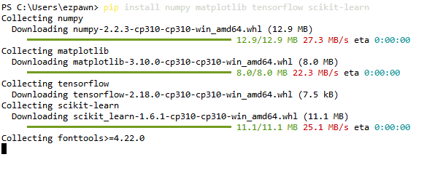

**Importing libraries (Erick)**

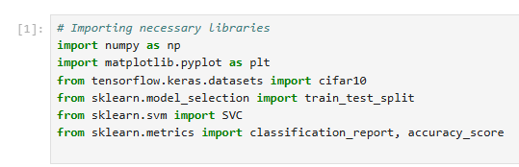

**Load Cifar-10 dataset (Erick)**

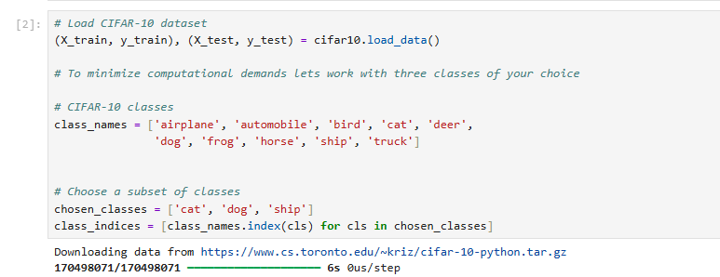

**Filter data (Erick)**

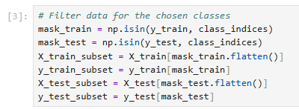

**Convert images to grayscale (Erick)**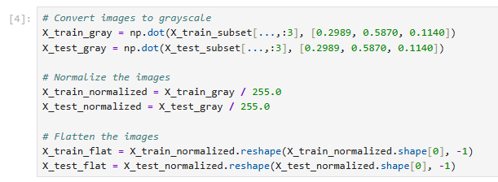

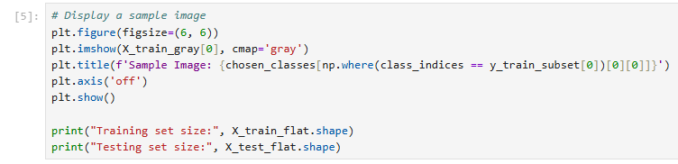

**Display a sample image(Erick)**

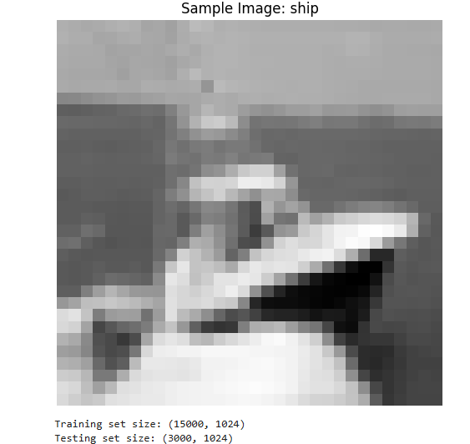

**Training a machine learning (Erick)**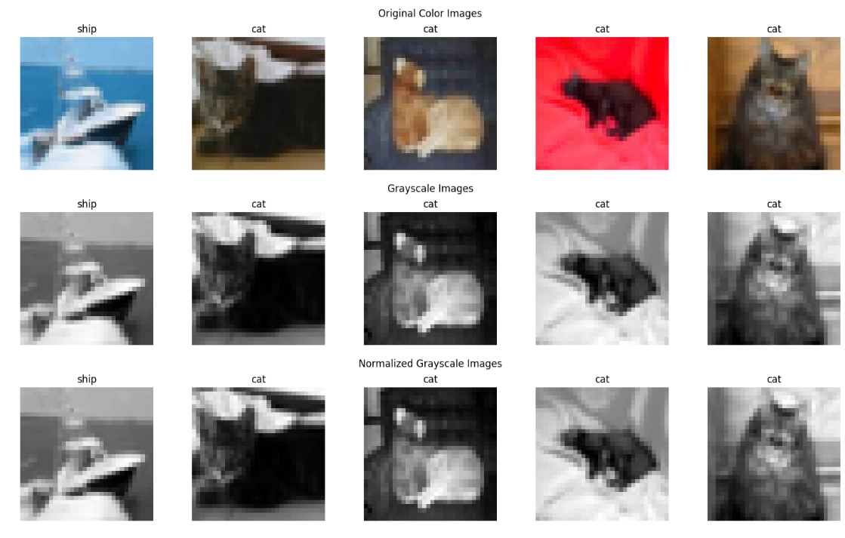

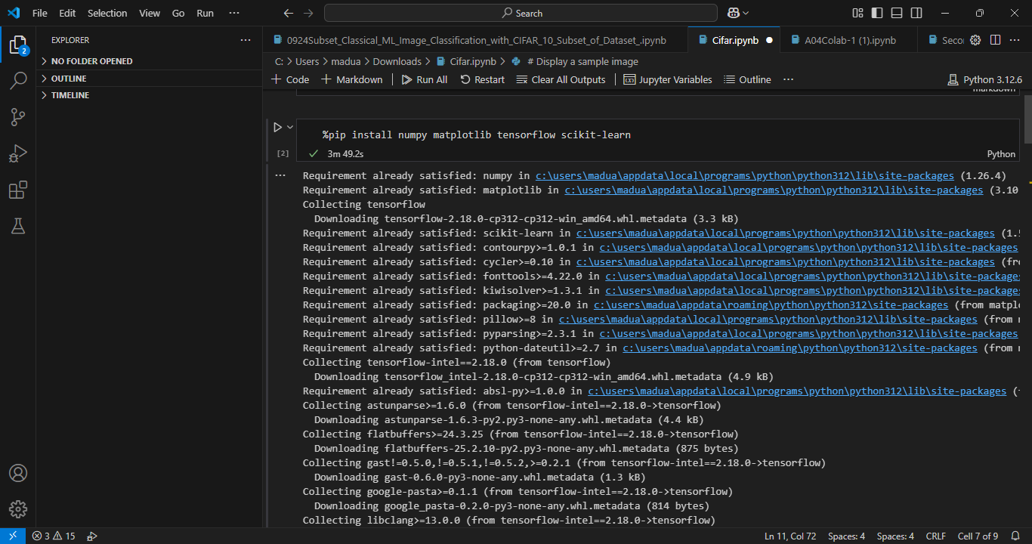

**Installing the necessary libraries (Melvis)**

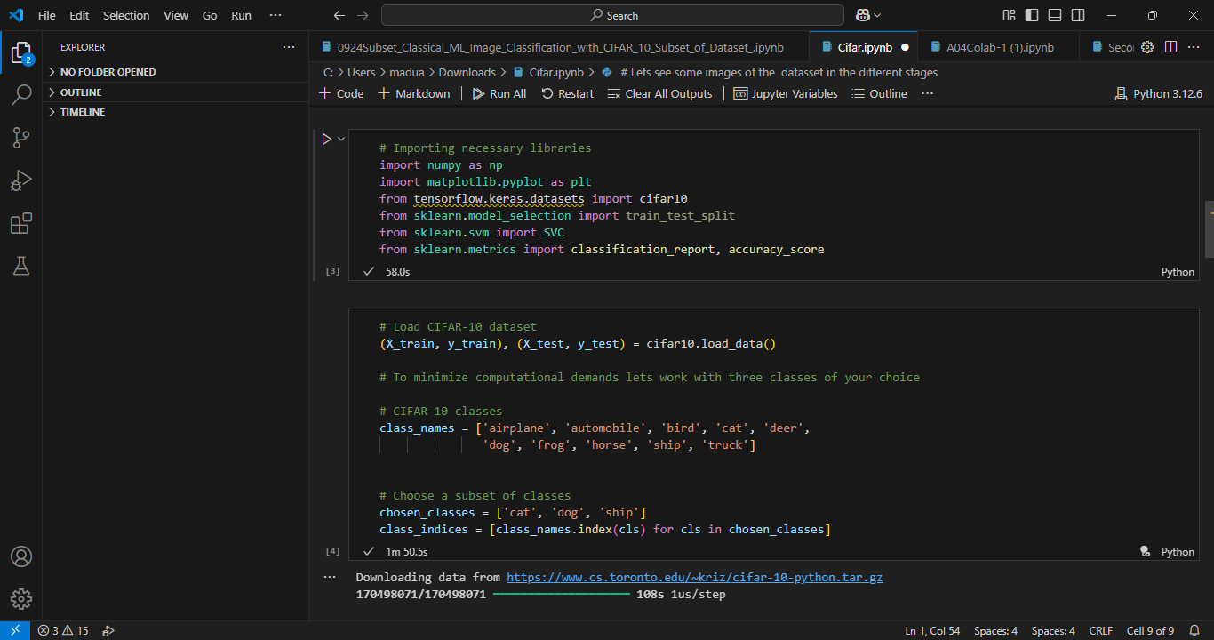

**Importing these libraries into the notebook and loading the CIFAR-10 dataset (Melvis)**

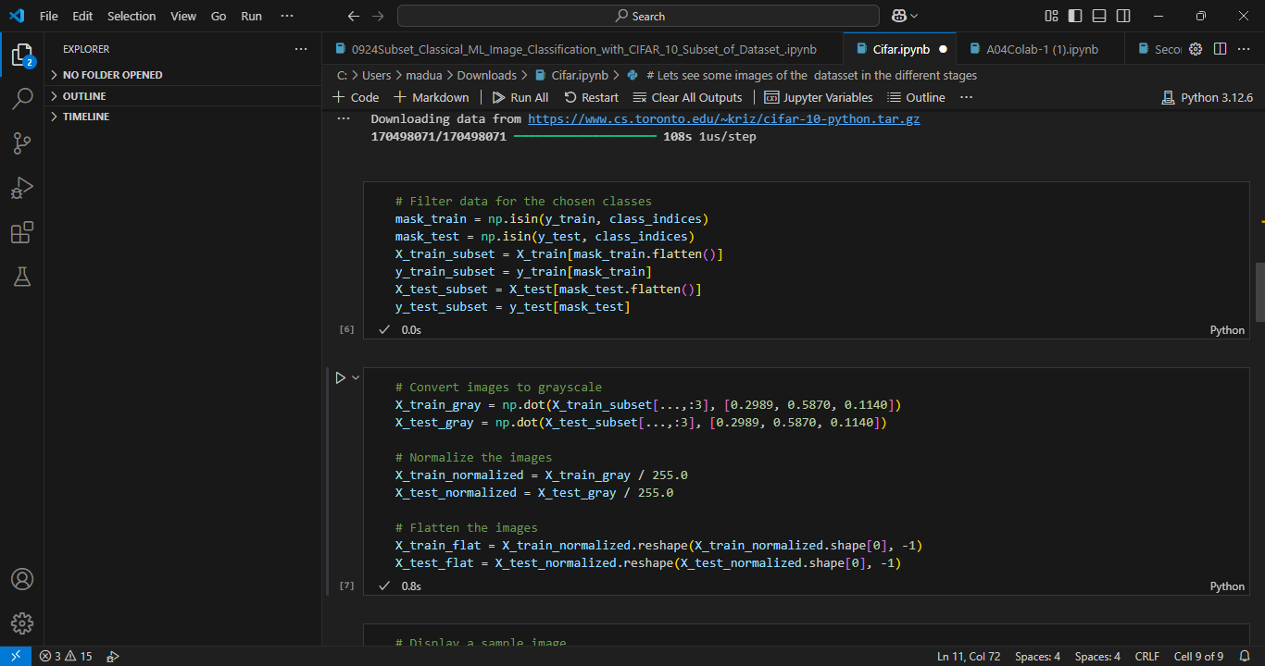

**Filtering data for the chosen classes and adjusting the images (Melvis)**

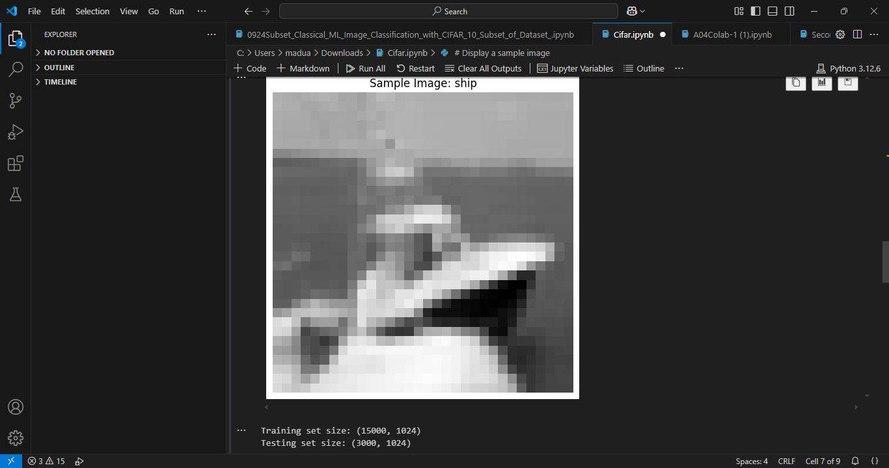

**Sample image (Melvis)**

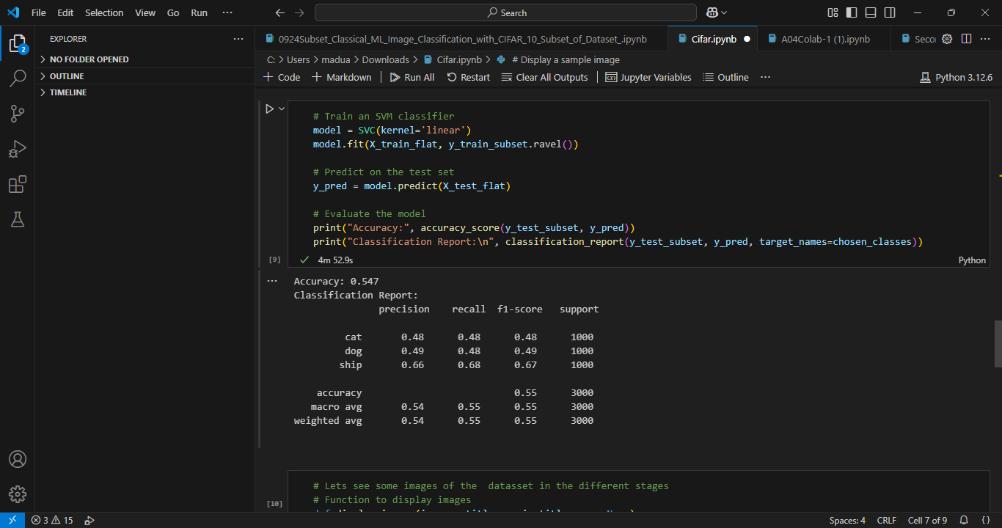

**Training and evaluating the model (Melvis)**

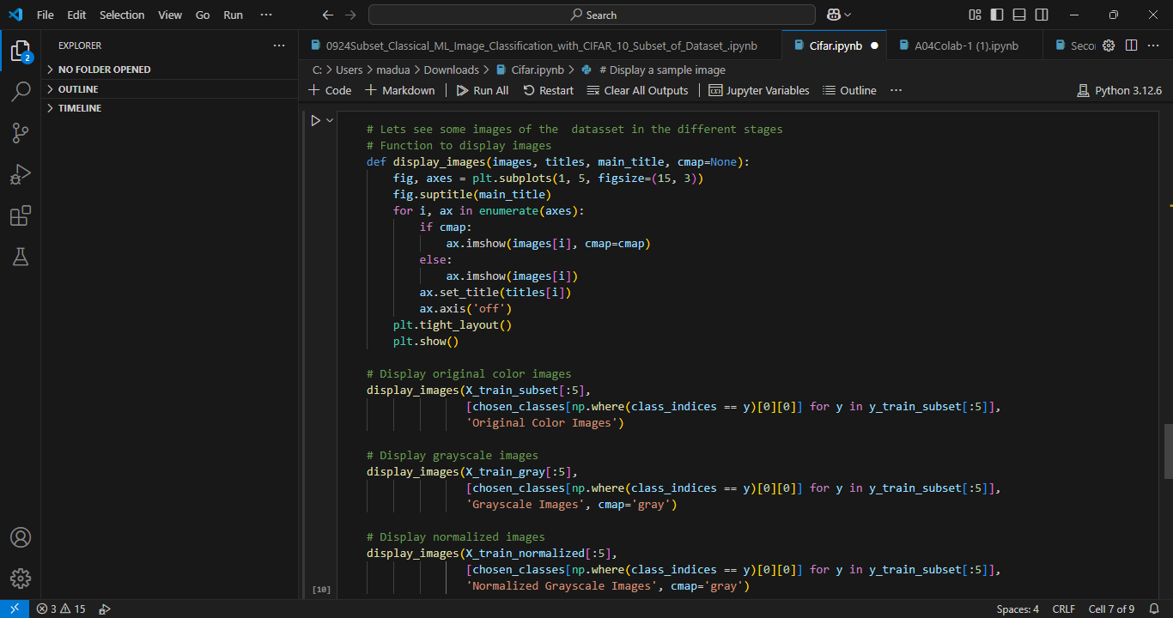

**Viewing the images in different stages (Melvis)**

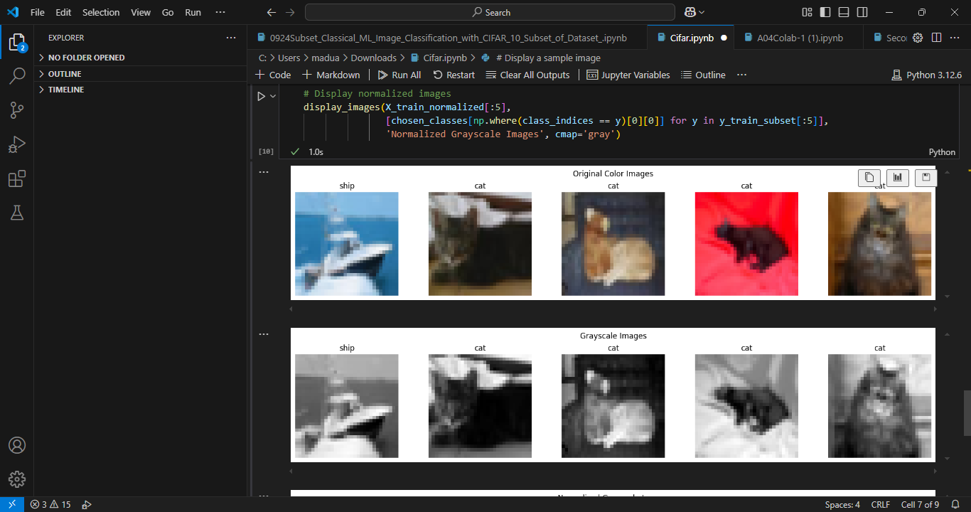

**Generated images (Melvis)**

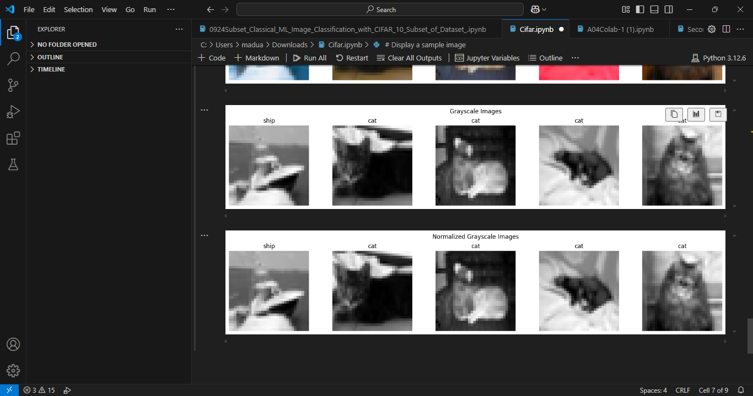

**Generated images (Melvis)**

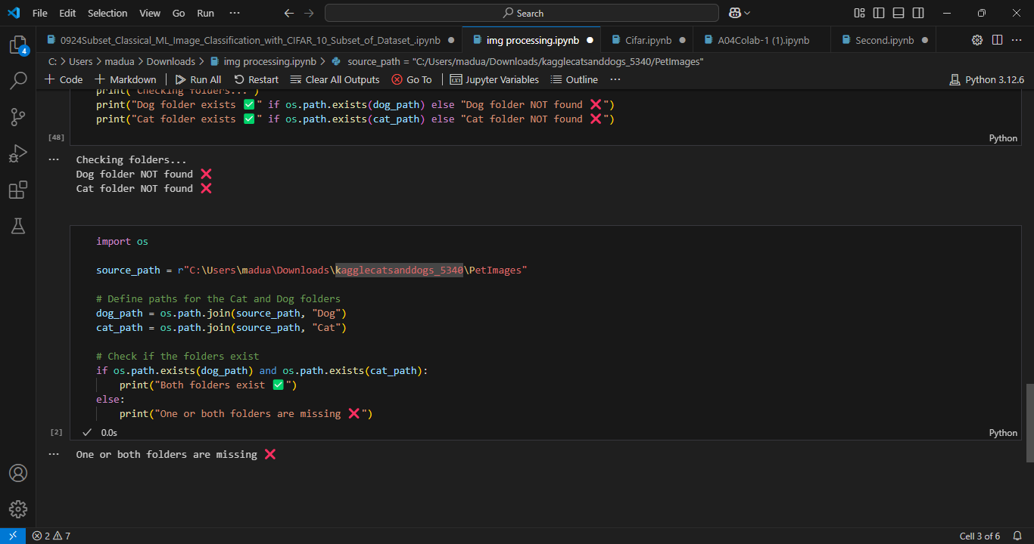

**Working on the 2014 image processing dataset (Melvis)**

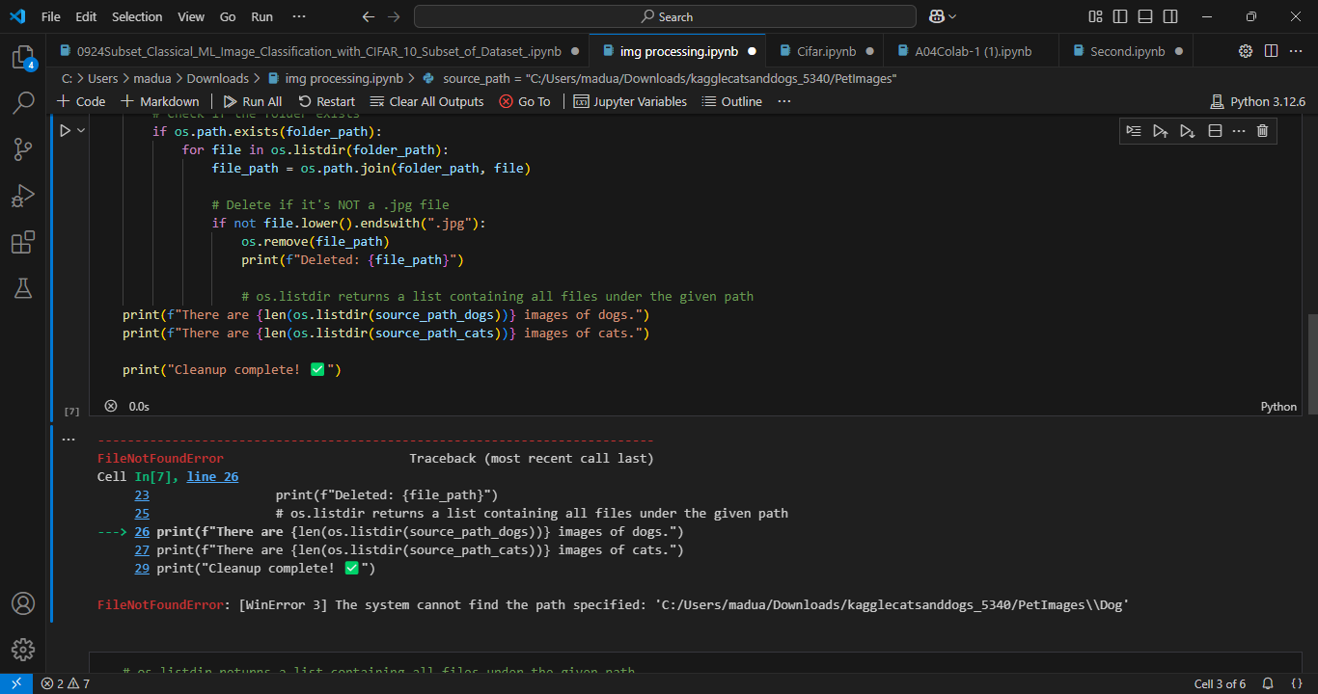

**Working on the 2014 image processing dataset (Melvis)**

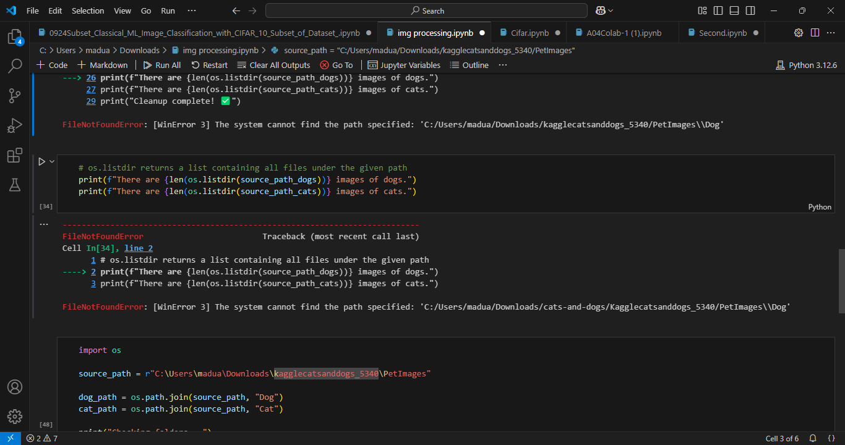

**Working on the 2014 image processing dataset (Melvis)**

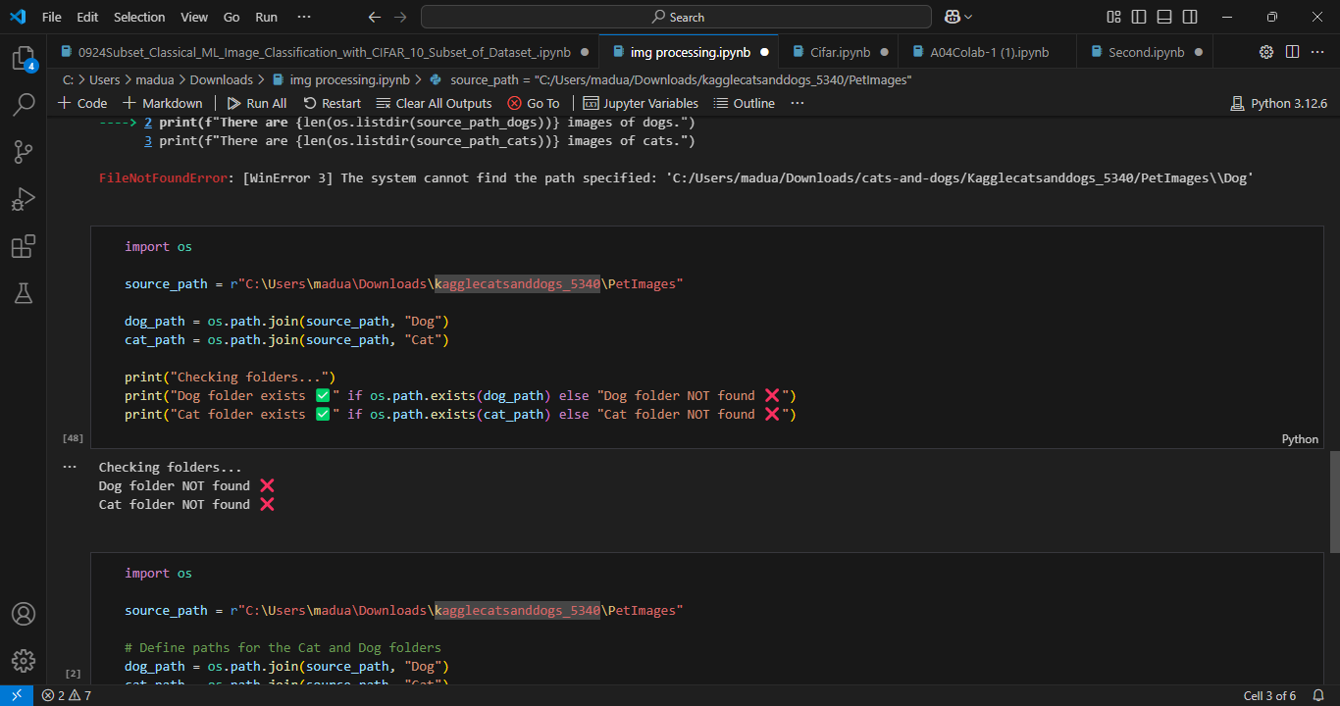**Working on the 2014 image processing dataset (Melvis)**

**2024 Image Processing and ML for CV with creating dataset Results**

##### 

**Fig 20: Importing Libraries (Matt)**

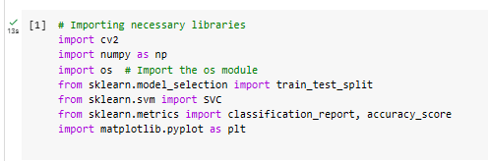

**Fig 20: Importing Libraries (Brooke)**

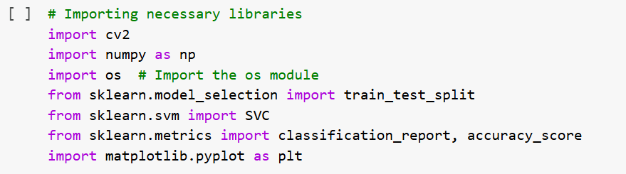

**Fig 20-N: Importing Libraries, Nancy**

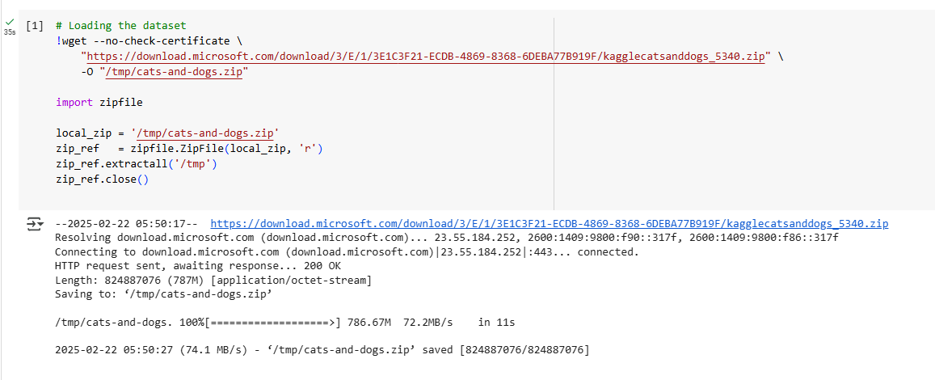

**Fig 21: Preparing the Dataset Part 1 (Matt)**

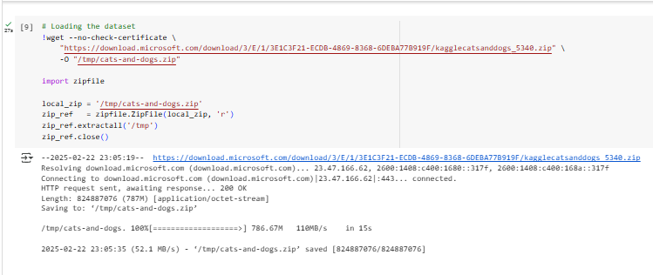

**Fig 21: Preparing the Dataset Part 1 (Brooke)**



**Fig 21-N: Preparing the Dataset Part 1, Nancy**

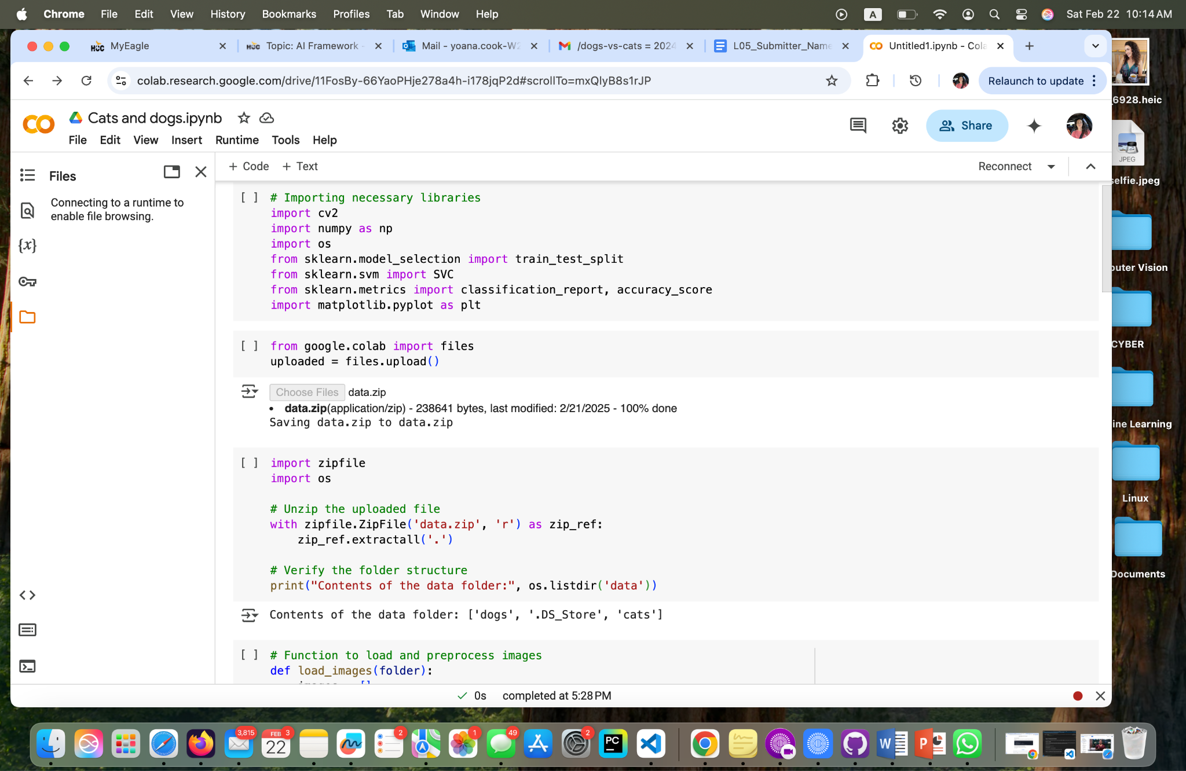

**Fig 21-Y: Importing Libraries & Preparing the Dataset Part 1 & 2, Yoana.**



**Fig 22: Preparing the Dataset Part 2 (Matt)**

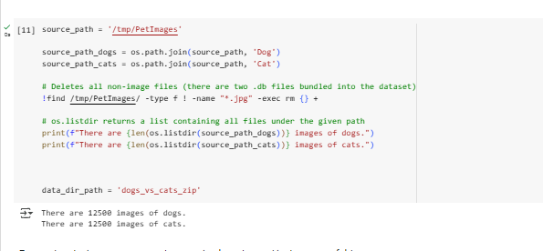

**Fig 22: Preparing the Dataset Part 2 (Brooke)**

**Fig 22-N: Preparing the Dataset Part 2, Nancy**

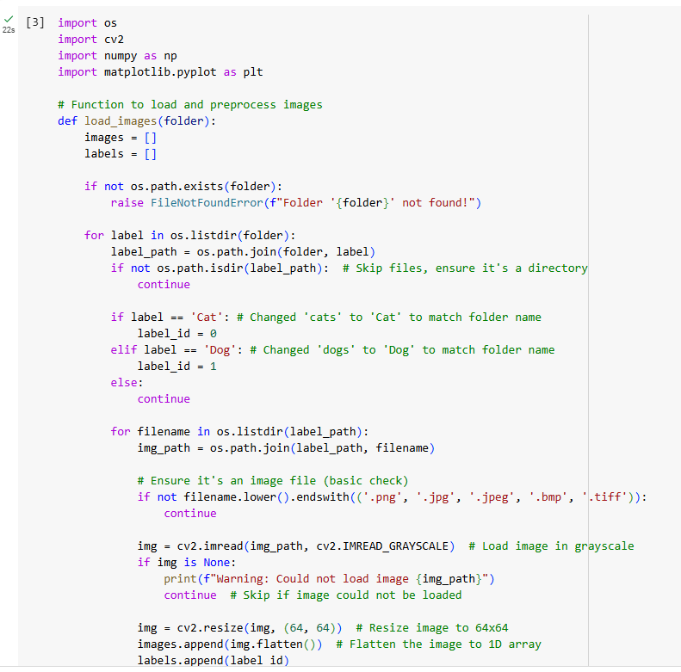

**Fig 23-N: Loading and Preprocessing Images Part 1, Nancy**



**Fig 23: Loading and Preprocessing Images Part 1 (Matt)**

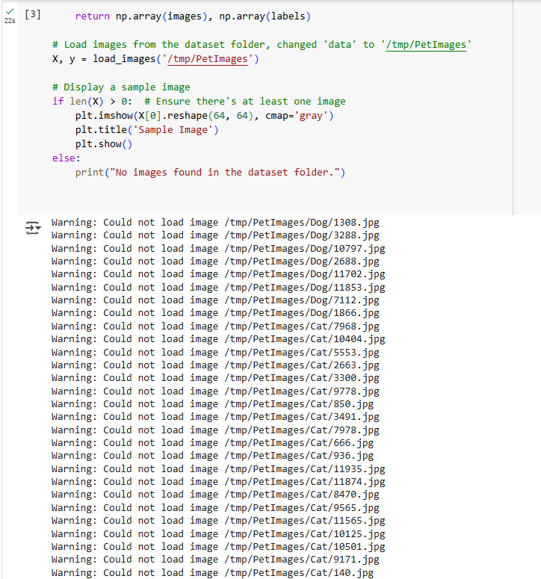

**Fig 24: Loading and Preprocessing Images Part 2 (Matt)**

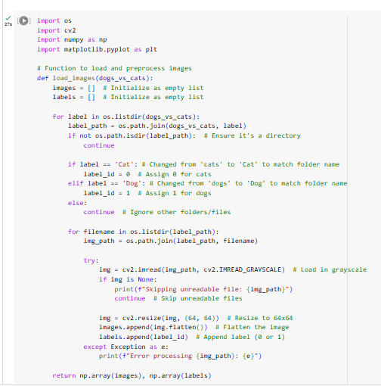

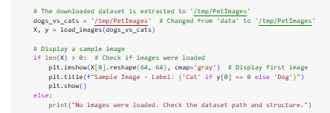

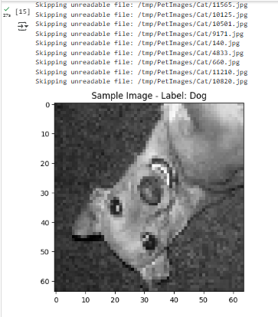

**Fig 23: Loading and Preprocessing Images (Brooke)**

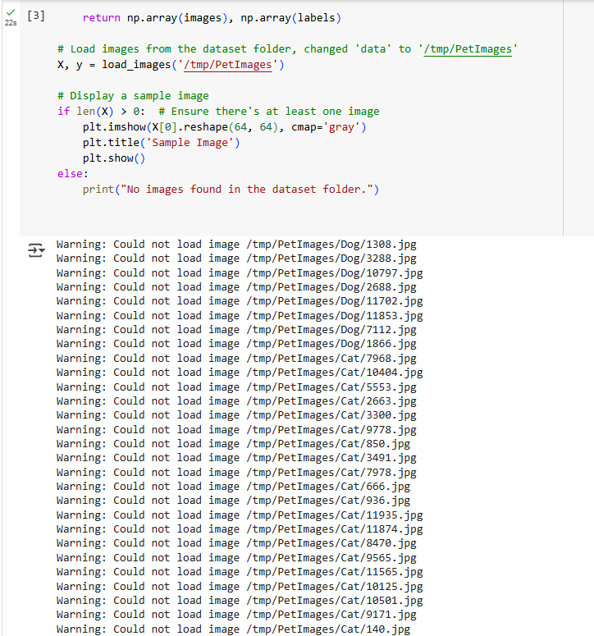

**Fig 24-N: Loading and Preprocessing Images Part 2, Nancy**

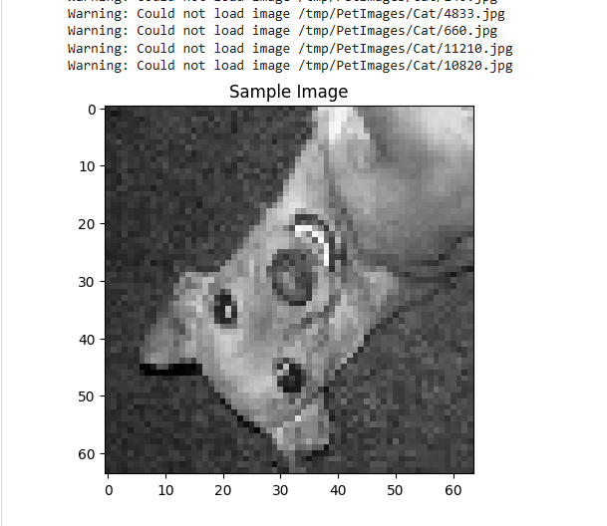

**Fig 25: Loading and Preprocessing Images Part 3 (Matt)**

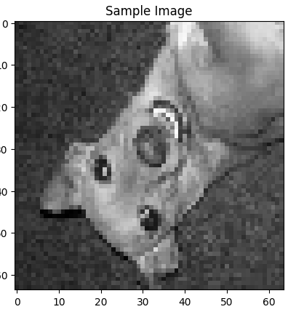

**Fig 25-N: Loading and Preprocessing Images Part 3, Nancy**

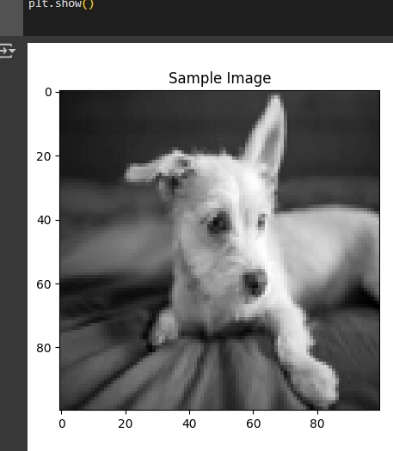

**Fig 25-C: Loading and Preprocessing Images Part 3, (Cam)**

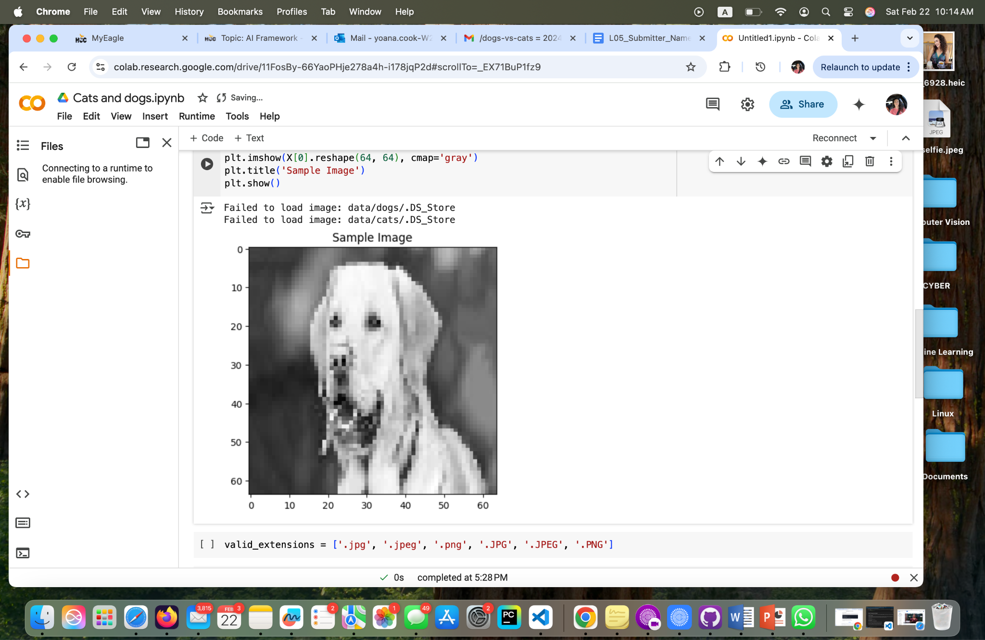

**Fig 25-Y: Loading and Preprocessing Images Part 3, Yoana.**

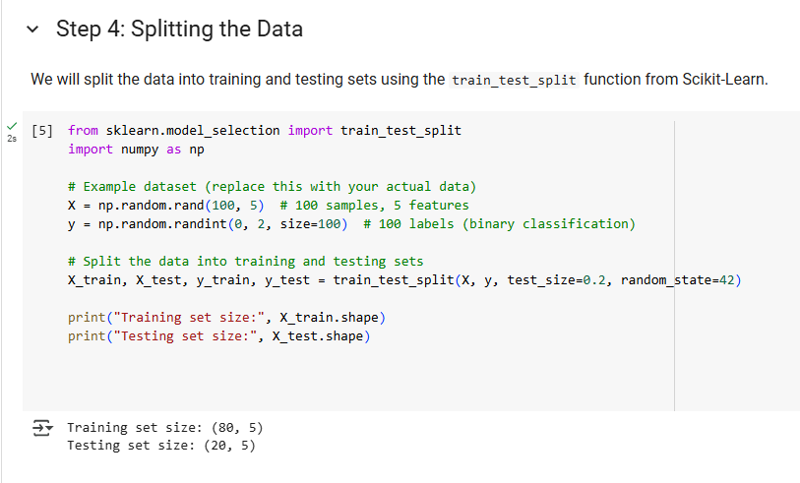

**Fig 26: Splitting the Data (Matt)**

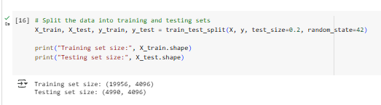

**Fig 26: Splitting the Data (Brooke)**

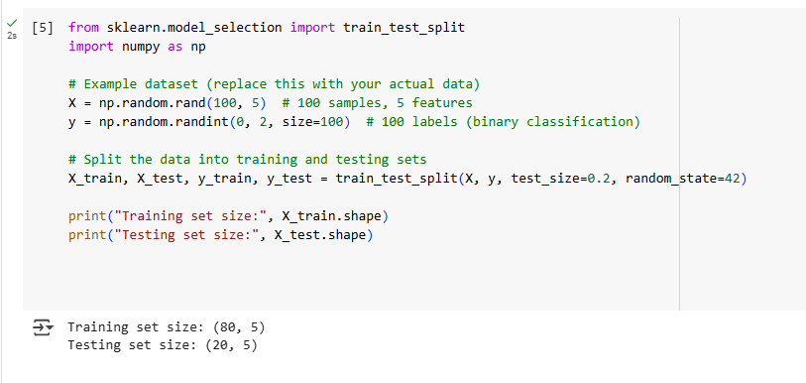**Fig 26-N: Splitting the Data, Nancy**

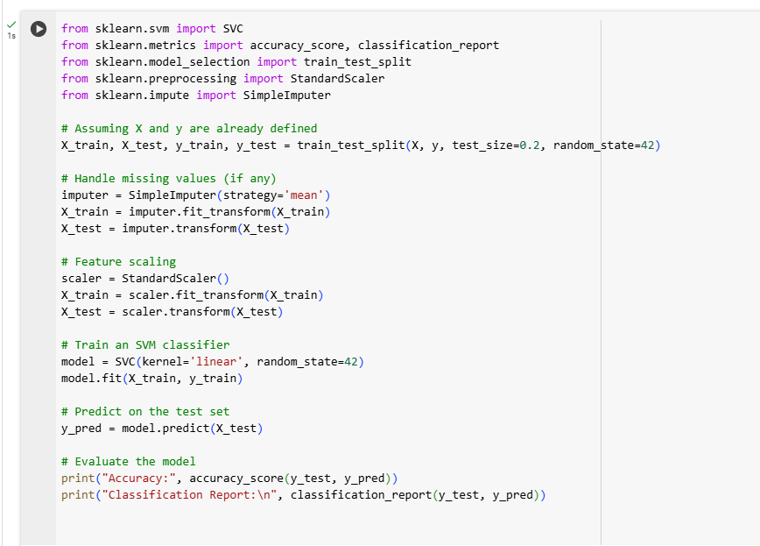

**Fig 27: Training a Machine Learning Model using SVM Part 1(Matt)**

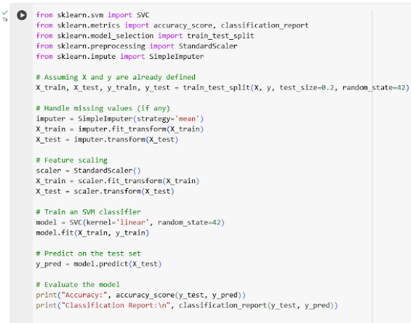

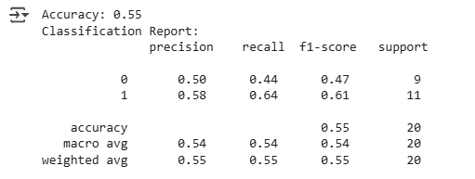

**Fig 27: Training a Machine Learning Model using SVM (Brooke)**

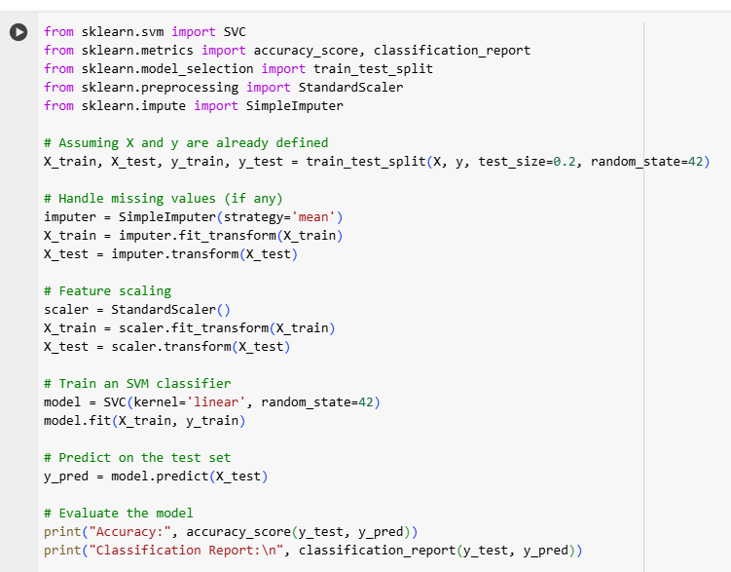

**Fig 27-N: Training a Machine Learning Model using SVM Part 1, Nancy**

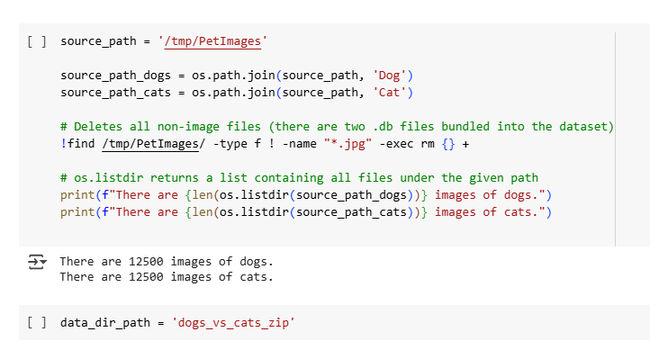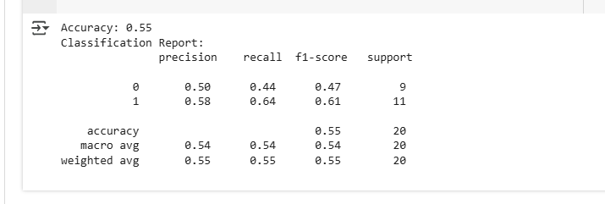

**Fig 28: Training a Machine Learning Model using SVM Part 2(Matt)**





**Fig 28-N: Training a Machine Learning Model using SVM Part 2, Nancy**

**Importing Libraries and Preparing the Dataset (Erick)**

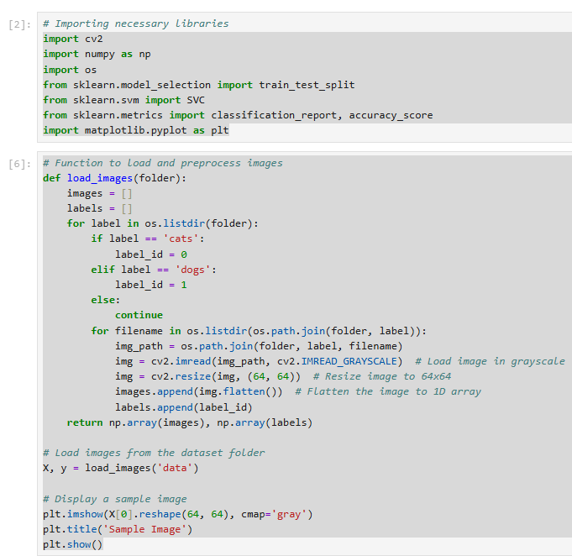

**Example (Erick)**

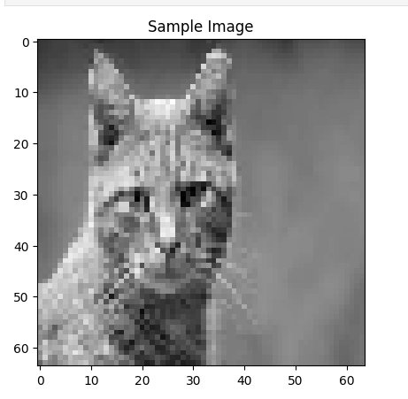

**Splitting the data and Training the SVM MODEL (Erick)**

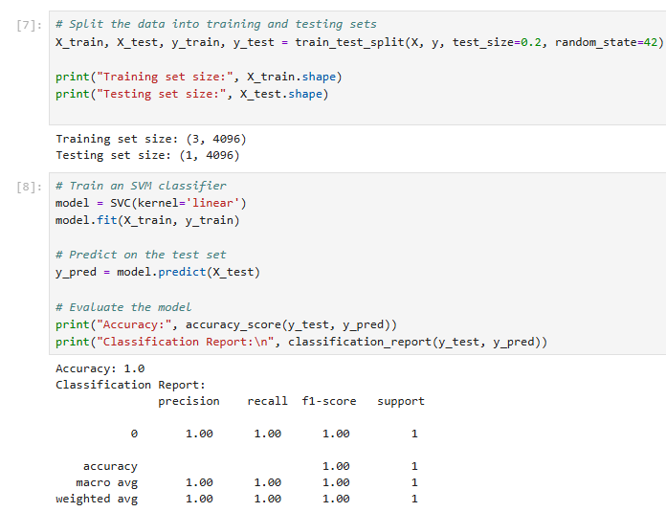

##### 

##### 

##### 

##### 

##### 

##### 

##### 

##### 

##### **Reflection**

**Brooke Broderick**

**0924Subset_Classical_ML_Image_Classification_with_CIFAR_10_Subset_of_Dataset**

* **For this lab, the task involved a classification task using Scikit-Learn. We trained the Support Vector Machine (SVM) classifier to extract features from the images. I experienced some errors with the code results and used the *Explain the Error* function within the Notebook, along with ChatGPT, to make corrections to the code. The instructions provided were easy to follow. My only gripe was that the coding issues were a nuisance but the tasks were not complex.**

**2024 Image Processing and ML for CV with creating dataset**

* **For this lab, the task involved building a simple cats vs. dogs classifier using Scikit-Learn. The approach taken was to prepare the dataset by collecting images of cats and dogs from Kaggle; load images and convert them to grayscale; and flattening the images. We trained the machine learning model on Support Vector Machine (SVM) which was ideal for this classification task. I ran into a few hiccups with the code loading and preprocessing of the images and used the *Explain the Error* function within the Notebook, along with ChatGPT, to make corrections to the code. I experienced a delay when running code for extracting features. The results of the classification report took well over an hour to load. This task was very challenging.**

**Matthew Choo**

**0924Subset_Classical_ML_Image_Classification_with_CIFAR_10_Subset_of_Dataset**

* **After running the codes there was some error in some of the codes. First in figure 11, we have to load the CIFAR-10 dataset, type in the classes and choose a subset from it. Later in Figures 12 to 15 we have to revise the code to print out the images. Next in figures 16 to 19, we have to train the machine learning model to produce different kinds of images such as original color images, grayscale images and normalized grayscale images. Overall this notebook was interesting but had to revise the code to have no errors.**

**2024 Image Processing and ML for CV with creating dataset**

* **This file was tough because of how we have to download a zip file from kaggle called dogs-vs-cats. In figure 20, we have to import these libraries before adding the zip file. From figures 21 to 22, we have to create and prepare the dataset for dogs and cats. Then, in figures 23 to 25 we will be loading and preprocessing the images from the file. After running the code, it shows that it could not load images. Next in figures 26 we will begin splitting the data from the file showing the training and testing set size. Lastly in figures 27 to 28 we will be training a machine learning model using SVM showing the accuracy and classification report. This ipynb was tricky and hard because of using the zip.file from kaggle.**

**Cameroun White**

**0924Subset_Classical_ML_Image_Classification_with_CIFAR_10_Subset_of_Dataset**

* **The first part of this was importing the proper libraries and then loading the CIFAR-10 dataset and preprocessing it by converting the images to grayscale flattening them. Thereafter, the program was able to display multiple variations of images in color and grayscale. This was fairly clear and concise but I made it through.**

**2024 Image Processing and ML for CV with creating dataset**

* **Not being as tech savvy as I would like to be made this one very difficult for me. I end up overthinking a lot because of my constant household distractions. Having to deal with the zip folder caused confusion for me because I was too busy trying to separate the images in the zip. With help from my classmates and ChatGPT and Gemini to help clarify a little more I was able to have Google Colab present a dog image successfully. I need to keep practicing but I feel like I'm understanding more and more.**

**Melvis Maduagwu**

**0924Subset_Classical_ML_Image_Classification_with_CIFAR_10_Subset_of_Dataset**

* **In this Lab, we learned how to use Machine learning to classify images. First we loaded and preprocessed the CIFAR-10 dataset. Next, we converted the images to grayscale and flattened them for features. We trained the model on the features and then checked the performance. The SVM was a really helpful tool for this Lab, but I would say I need to learn more about it.**

**2024 Image Processing and ML for CV with creating dataset**

* **This part of the assignment was pretty challenging for me. I engaged with it for 10 hours with no good results. It gave me a lot of errors. I may have to look well into it and find the root problems.**

**Erick Banegas**

**0924Subset_Classical_ML_Image_Classification_with_CIFAR_10_Subset_of_Dataset**

* **While working with the code, the first step was loading the CIFAR-10 dataset, defining the classes, and selecting a specific subset for analysis. Then, adjustments were made to properly display the images and explore their characteristics. Later, the machine learning model was trained to generate different types of images, including color versions, grayscale, and normalized grayscale images. Overall, the notebook provided an engaging experience, allowing for experimentation with various approaches to image processing and transformation.**

**2024 Image Processing and ML for CV with creating dataset**

* **Working on this part made me realize the importance of properly handling data before using it in a model. I had to validate images to avoid errors and ensure everything was processed correctly. Resizing, normalizing, and flattening images were key steps to keep the data consistent. Overall, it was a good exercise in making the code more reliable and adaptable.**

**NancyChieu**

**0924Subset_Classical_ML_Image_Classification_with_CIFAR_10_Subset_of_Dataset**

* **By using Google Colab I was able to find my 0924 in my Google Drive. I followed the steps in the file and imported the needed libraries all together, numpy, matplotlib, tensorflow, sklearn from CIFAR 10. These libraries help to train and evaluate machine learning for image classification. I loaded the dataset from the libraries and converted the images to grayscale and flatten them. Next I used SVM which is a supervised learning model to classify images. SVM is an effective model when the number of features is large, such as the training set size is 15000 and the testing set is 3000 for the ship sample. I found that SVM is a good model for me to learn how to do image classification with machine learning even though the accuracy rate is 0.547 for cat, dog and ship classification.**

**2024 Image Processing and ML for CV with creating dataset**

* **This image processing is rather difficult for me and we do need a lot of help to understand and complete this image processing. I learned from my team members to download a dogs-vs-cats zip file from kaggle. Next we imported needed libraries as in F 20, then prepared the dataset and processed it. It kept showing that the image could not be loaded. With lots of trial and error, we learned to split the training and testing data sizes. Finally we were able to use SVM to train and evaluate the ML for image classification. The report showed the accuracy of 0.55.**

**Yoana Cook:**

**0924Subset_Classical_ML_Image_Classification_with_CIFAR_10_Subset_of_Dataset**

* **In this assignment I have worked on an image classification task using the CIFAR-10 dataset. The goal was to load the dataset, extract features from images, train a machine learning model, and evaluate its performance. In the process I have used a few imported libraries: *NumPy:* Which helped with numerical operations, like handling arrays. *Matplotlib:* Used to visualize the images from the dataset. *TensorFlow:* Provided easy access to the CIFAR-10 dataset, saving time. *Scikit-Learn:* The main library for training** **and evaluating the machine learning model. What I did is: *Loaded and Preprocessed the CIFAR-10 Dataset*: I used TensorFlow to import the dataset, which contains 60,000 small color images of 10 different objects (like cats, dogs, and airplanes). Then, *Extracted Features:* Using methods to extract useful features from the images. *Trained a Machine Learning Model:* Applying a traditional machine learning approach (instead of deep learning) to classify the images. *Evaluated the Model*: Finally, I checked how well the model performed using accuracy and other evaluation metrics.**

**The model was able to classify images, but since I used classical machine learning instead of deep learning, the accuracy was not as high as modern neural networks. However, this was a great learning experience because it showed how feature extraction plays a role in classification tasks. Overall, this assignment helped me understand the step-by-step process of image classification and how different libraries work together to make machine learning projects to implement.**

**2024 Image Processing and ML for CV with creating dataset**

* **This assignment honestly challenged me a lot. My main goal was to work with image classification and dataset creation, which involved several key steps: importing a dataset, preprocessing images, training a model, and evaluating its performance. Extracting the dataset from Kaggle and getting the token was very easy, but it turned into a long trial-and-error process afterwards. I used two YouTube videos, *"How to import Kaggle datasets in Google Colab"* and *"Loading Kaggle data directly into Google Colab"*. The two methods worked, but somehow going onward with code it kept giving me errors. No matter how many times I followed the steps, I kept running into errors. I went back and forth with Gemini and ChatGPT for five days trying to figure out why the method was not working. They were providing me with updated codes, supposedly compatible, but still I kept running into the same or different issues and seemed like I kept getting deeper into the rabbit hole. Hallelujah! On Friday evening, I finally figured it out! Instead of uploading the Kaggle dataset directly, I created my own folder, with sub folders of “cats” and “dogs” (simply just followed the assignment requirements), mainly uploaded the pictures of cats and dogs and zipped the folder, and it worked, when I saw the dog head appear I felt so relieved. The only extra command I needed to add was:**

**from google.colab import files   
 uploaded = files.upload()**

**After adding these two lines, it worked perfectly! Then with that simple command it worked with importing the Kaggle dataset as well. I could not believe how much time I had spent going in circles when the solution was so simple.**

**The libraries that I used were: *NumPy* : Which helped handle numerical data efficiently. *Matplotlib:* Allowing to visualize images from my dataset. *TensorFlow/Keras:* Provided essential tools for working with images and building models. *Scikit-Learn:* Used for feature extraction and evaluating model performance.**

**Despite the initial struggles, I am glad I learned about Kaggle and its functions. I had never really thought about where scientists and data analysts get their large datasets from, but it makes perfect sense that there is a dedicated platform specifically for storing and sharing them. Once I got past the import issues, the rest of the assignment went smoothly and easily. This experience taught me that sometimes the simplest solutions are right in front of us, and persistence pays off!**

Bibliography

“Dogs vs. Cats.” Kaggle, www.kaggle.com/competitions/dogs-vs-cats/overview.

Accessed 19 Feb. 2025.

“Download Kaggle Cats and Dogs Dataset from Official Microsoft Download Center.”

Microsoft Store - Download Center,

www.microsoft.com/en-us/download/details.aspx?id=54765. Accessed 22 Feb. 2025.

##### 

##### 

##### 

##### 